**Modulabschlussprüfung Programmierung II**

**Repertorium**

* div. Beispielaufgaben
* Modulabschlussprüfung

**Kapitel 1 – Einführung git & GitHub**

* Theorie

**Kapitel 2 - Numerisches Python I**

* Theorie
* Vorlesung
* Übung
* Beispielaufgaben (numpy / matplotlip)

**Kapitel 3 – Objektorientierung, Teil 1**

* Theorie
* Vorlesung
* Übung

**Kapitel 4 – Objektorientierung, Teil 2**

* Theorie
* Vorlesung
* Übung

**Kapitel 5 – Objektorientierung, Teil 3**

**Theorie**

* Vorlesung
* Übung
* Beispielaufgaben (class)

**Kapitel 6 – GUI Programmierung, Teil 1**

* Theorie
* Vorlesung
* Übung
* Zusammenfassung GUI

**Kapitel 7 – GUI Programmierung, Teil 2**

* Theorie
* Vorlesung
* Übung

[**Kapitel 8 – GUI Programmierung:  
QtDesigner**](#_Kapitel_8_–)

* Theorie
* Vorlesung
* Übung
* Beispielaufgaben (qt)

**Kapitel 9 – Matplotlib & Qt**

* Theorie
* Vorlesung
* Übung

**Kapitel 10 – Projektionen und Vektordaten, Teil 1: Shapely**

* Theorie
* Vorlesung
* Übung

**Kapitel 11 – Folium & GeoPandas**

* Übung
* Beispielaufgaben (panda)

**Kapitel 12 – Projektionen & Vektordaten, Teil 2: cartopy**

* Vorlesung
* Übung

# Repertorium

# Kapitel 1 – Einführung git & GitHub

# Kapitel 2 - Numerisches Python I

## Vorlesung:

* **01_example.py**

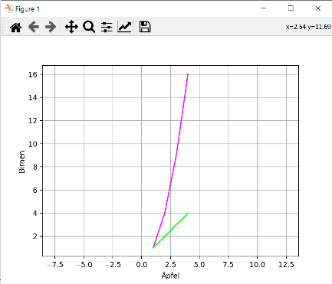import matplotlib.pyplot as plt

plt.plot([1,2,3,4], [1,4,9,16], color="#FF00FF")

plt.plot([1,2,3,4], [1,2,3,4], color="#00FF00")

plt.xlabel("Äpfel")

plt.ylabel("Birnen")

plt.axis("equal")

plt.grid(True)

plt.show()

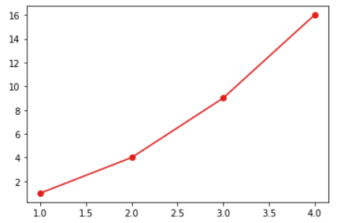

* **02_plotten.ipynb**

import matplotlib.pyplot as plt

plt.plot([1,2,3,4], [1,4,9,16], "ro-");

p

* **03_sinuskurve.py**

import matplotlib.pyplot as plt

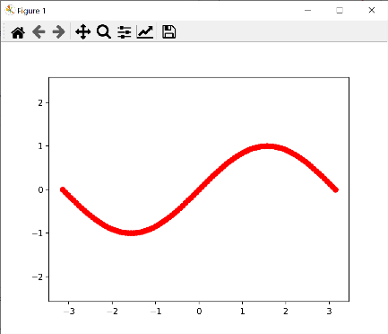import math

s = 2*math.pi

n = 100

teilstück = s / n

xlist = []

ylist = []

for i in range(0,n+1):

    x = -math.pi + i*teilstück

    xlist.append(x)

    y = math.sin(x)

    ylist.append(y)

plt.plot(xlist,ylist, "ro--")

plt.axis("equal")

plt.show()

* **04_numerik.py**

import numpy as np

a = np.array([1,2,3,4], dtype=np.float64)

b = np.array(list(range(0,11))) / 10

c = np.array([ [1,2,3],[4,5,6],[7,8,9] ])

Output:

[1 4 7]

(3,3)

False

print(c[:,0])

print(c.shape)

print(10 in c)

* **05_arrays.ipynb**

import numpy as np

np.zeros([3,4])

array([[0., 0., 0., 0.],

[0., 0., 0., 0.],

[0., 0., 0., 0.]])

np.ones([8,7])

array([[1., 1., 1., 1., 1., 1., 1.],  
 [1., 1., 1., 1., 1., 1., 1.],  
 [1., 1., 1., 1., 1., 1., 1.],  
 [1., 1., 1., 1., 1., 1., 1.],  
 [1., 1., 1., 1., 1., 1., 1.],  
 [1., 1., 1., 1., 1., 1., 1.],  
 [1., 1., 1., 1., 1., 1., 1.],  
 [1., 1., 1., 1., 1., 1., 1.]]

a = np.zeros([3,3])

a[2,2] = 5

a

array([[0., 0., 0.],  
 [0., 0., 0.],  
 [0., 0., 5.]])a = np.arange(0,10)

a

array([0, 1, 2, 3, 4, 5, 6, 7, 8, 9])

a = np.arange(0,10.5,0.5)

a

array([ 0. , 0.5, 1. , 1.5, 2. , 2.5, 3. , 3.5, 4. , 4.5, 5. ,  
 5.5, 6. , 6.5, 7. , 7.5, 8. , 8.5, 9. , 9.5, 10. ])

a = np.linspace(0,1, 11)

a

array([0. , 0.1, 0.2, 0.3, 0.4, 0.5, 0.6, 0.7, 0.8, 0.9, 1. ]

np.pi * a

array([0. , 0.31415927, 0.62831853, 0.9424778 , 1.25663706,  
 1.57079633, 1.88495559, 2.19911486, 2.51327412, 2.82743339,  
 3.14159265])

np.random.random(10)*100

array([85.02796136, 57.83834166, 87.29521745, 49.53857336, 21.20886912,  
 73.30682197, 68.52896197, 47.9098261 , 67.81530219, 7.82074031])

* **06_numpyplot.py**

import numpy as np

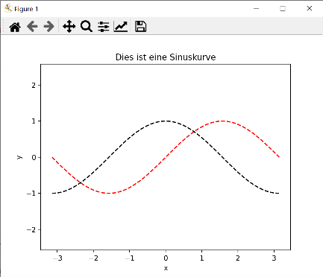import matplotlib.pyplot as plt

x = np.linspace(-np.pi, np.pi, 100)

y = np.sin(x)

y2 = np.cos(x)

plt.plot(x,y,"r--")

plt.plot(x,y2,"k--")

plt.axis("equal")

plt.title("Dies ist eine Sinuskurve")

plt.xlabel("x")

plt.ylabel("y")

plt.show()

* **07_subplot.py**

import numpy as np

import matplotlib.pyplot as plt

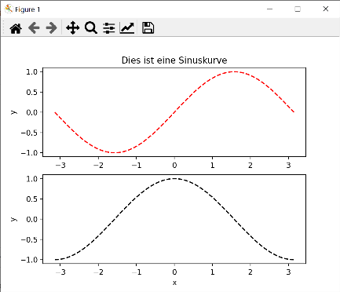

x = np.linspace(-np.pi, np.pi, 100)

y = np.sin(x)

y2 = np.cos(x)

plt.subplot(2,1,1)

plt.title("Dies ist eine Sinuskurve")

plt.plot(x,y,"r--")

plt.xlabel("x")

plt.ylabel("y")

plt.subplot(2,1,2)

plt.plot(x,y2,"k--")

plt.xlabel("x")

plt.ylabel("y")

plt.show()

* **Eigene_Python_module_importieren.ipynb**

Die python Datei numerik.py mit folgenden Inhalt:

import numpy as np

a = np.array([1,2,3,4], dtype=np.float64)

b = np.array(list(range(0,11))) / 10

c = np.array([ [1,2,3],[4,5,6],[7,8,9] ])

new_var = np.random.random(10)

lässt sich wie ein normales python Modul importieren (dafür muss die Datei in dem gleichen Ordner gespeichert sein, sonst müsste man die sys.path Variable anpassen...).

import numerik

from numerik import new_var

* **Hilfe_Funktionen.ipynb**

**help(), func? und func??**

# was macht meshgrid überhaupt?

help(np.meshgrid)

# das gleiche wie oben

np.meshgrid?# docstring + source code

np.meshgrid??

# Kapitel 3 – Objektorientierung, Teil 1

## Vorlesung

* **01_beispiel.py**

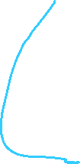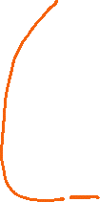

punkt.py

# Klassendefinition

class Punkt:

    def __init__(self, x=0, y=0):

        self.x = x

        self.y = y

    def ausgabe(self, untereinander):

        if untereinander:

            print("x=", self.x)

            print("y=", self.y)

        else:

            print(f"Punkt: [{self.x},{self.y}]")

    def distanz(self, b):

        return ((self.x-b.x)**2 + (self.y-b.y)**2)**0.5

if __name__ == "__main__":

    a = Punkt(3,4)

    b = Punkt(2,4)

    a.ausgabe(False)

    b.ausgabe(False)

    print(a.distanz(b))

import punkt

Output:

x= 0

y= 0

Punkt: [1.2,1.1]

1.6278820596099708

1.6278820596099708

0.0

a = punkt.Punkt() # Instanz

b = punkt.Punkt(1.2,1.1) # Instanz

a.ausgabe(True)

b.ausgabe(False)

d1 = a.distanz(b)

d2 = b.distanz(a)

d3 = a.distanz(a)

print(d1)

print(d2)

print(d3)

* **02_temperatur.py**

class Temperatur:

    def __init__(self, celsius=0):

        self.setValue(celsius)

    def setValue(self, v):

        if v < -273.15:

            print("Warnung: Temperatur-Wert wurde korrigiert auf -273.15 Celsius")

            v = -273.15

            #raise ValueError("Absoluter Nullpunkt ist -273.15 Celsius")

        self._value = v

    def getValue(self):

        return self._value

    def setValueF(self, f):

        self.setValue((f-32) / 1.8)

    def getValueF(self):

        c = self.getValue()

        f = c * 1.8 + 32

        return f

    celsius = property(getValue, setValue)

    fahrenheit = property(getValueF, setValueF)

## ---------------------------------------------------------

Output:

20

68.0

37.77777777777778

Warnung: Temperatur-Wert wurde korrigiert auf -273.15 Celsius

t0 = Temperatur(20)

print(t0.celsius)

print(t0.fahrenheit)

t1 = Temperatur()

t1.fahrenheit = 100

print(t1.celsius)

t1.fahrenheit = -1000

# Kapitel 4 – Objektorientierung, Teil 2

## Vorlesung

* **temperatur.py**

class Temperatur:

    def __init__(self, c):

        self.celsius = c

    def __str__(self):

        return str(self.celsius) + chr(8451)

    def __gt__(self, other):

        return self.celsius > other.celsius

    def __lt__(self, other):

        return self.celsius < other.celsius

    def __eq__(self, other):

        return self.celsius == other.celsius

t_muttenz = Temperatur(9.0)

t_zurich = Temperatur(11)

print(t_muttenz)

if t_zurich > t_muttenz:

    print("😡😡😡😡😡😡😡😡")

else:

    print("HAHAHA")

if t_zurich == t_muttenz:

    print("ok")

* **tempservice.py**

apikey.py

# rename this file to apikey.py

# api_key = "<INSERT API-KEY HERE>"

import requests

import apikey

class Temperatur:

    def __init__(self, city):

        url = f"https://api.openweathermap.org/data/2.5/weather?q={city}&appid={apikey.api_key}&units=metric"

        data = requests.get(url)

        x = data.json()["main"]

        self.celsius = x["temp"]

        self.city = city

    def __str__(self):

        return f"Temperatur in {self.city} ist {self.celsius} {chr(8451)}"

    def __gt__(self, other):

        return self.celsius > other.celsius

    def __ge__(self, other):

        return self.celsius >= other.celsius

    def __lt__(self, other):

        return self.celsius < other.celsius

    def __le__(self, other):

        return self.celsius <= other.celsius

    def __eq__(self, other):

        return self.celsius == other.celsius

    def __ne__(self, other):

        return self.celsius != other.celsius

t_zurich = Temperatur("Zürich,Switzerland")

t_basel = Temperatur("Basel,Switzerland")

print(t_zurich)

print(t_basel)

if t_zurich > t_basel:

    print("oh, nein!!!!!! ARGH!!!!")

else:

    print("Juhuuuu!!!!")

* **vector2.py**

class Vector2:

    def __init__(self, x=0, y=0):

        self.x = x

        self.y = y

    def __add__(self, other):

        return Vector2(self.x+other.x, self.y+other.y)

    def __sub__(self, other):

        return Vector2(self.x-other.x, self.y-other.y)

    def __mul__(self, other):

        if type(other) == int or type(other) == float:

            return Vector2(self.x * other, self.y * other)

        else:

            return Vector2(self.x*other.x, self.y*other.y)

    def __rmul__(self, other):

        if type(other) == int or type(other) == float:

            return Vector2(self.x * other, self.y * other)

        else:

            return Vector2(self.x*other.x, self.y*other.y)

    def __neg__(self):

        return Vector2(-self.x, -self.y)

    def __str__(self):

        return f"VECTOR ({self.x} {self.y})"

#------------------------------------------------------------------------------

a = Vector2(3,4)

b = Vector2(2,3)

c = Vector2(4,5)

resultat = ( a + b + c ) + a + b + a + b + ( c + a ) + a + a

print(resultat) ------------- Output ------------------> VECTOR (32 43)

a = Vector2(4,5)

b = Vector2(2,3)

c = a * b

print(c) ------------- Output ------------------> VECTOR (8 15)

d = a * 2

print(d) ------------- Output ------------------> VECTOR (8 10)

d = 2 * a

print(d) ------------- Output ------------------> VECTOR (8 10)

a = Vector2(1,2)

b = Vector2(2,3)

c = Vector2(2,2)

d = a + (b * c)

print(d) ------------- Output ------------------> VECTOR (5 8)

a = Vector2(1,2)

a += Vector2(1,1)

print(a) ------------- Output ------------------> VECTOR (2 3)

b = -a

print(b) ------------- Output ------------------> VECTOR (-2 -3)

# Kapitel 5 – Objektorientierung, Teil 3 Theorie

## Vorlesung

* **01_HatBeziehung.py**

class Studiengang:

    def __init__(self, hochschule, name):

        self.hochschule = hochschule

        self.name = name

## -------------------------------------------

class Kurs:

    def __init__(self, name):

        self.name = name

        self.students = []

    def addStudent(self, student):

        self.students.append(student)

    def __str__(self):

        s = "KURS: " + self.name + "\n"

        for student in self.students:

            s += student.vorname + " " + student.nachname + " " + student.studiengang.name + "\n"

        return s

## -------------------------------------------

class Student:

    def __init__(self, vorname, nachname, geschlecht, studiengang):

        self.matrikelnummer = ""

        self.vorname = vorname

        self.nachname = nachname

        self.adresse = ""

        self.studiengang = studiengang

        self.geschlecht = geschlecht

geomatik = Studiengang("HABG", "Geomatik")

architektur = Studiengang("HABG", "Architektur")

student1 = Student("Hans", "Meier", "m", geomatik)

student2 = Student("Alexandra", "Müller", "w", geomatik)

student3 = Student("Joachim", "Huber", "m", architektur)

Output:

KURS: Programmieren

Hans Meier Geomatik

Alexandra Müller Geomatik

Joachim Huber Geomatik

KURS: DBV

Hans Meier Geomatik

Joachim Huber Geomatik

KURS: Programmieren

Franz Meier Geomatik

Alexandra Müller Geomatik

Joachim Huber Geomatik

student3.studiengang = geomatik

prog = Kurs("Programmieren")

prog.addStudent(student1)

prog.addStudent(student2)

prog.addStudent(student3)

dbv = Kurs("DBV")

dbv.addStudent(student1)

dbv.addStudent(student3)

print(prog)

print(dbv)

student1.vorname = "Franz"

print(prog)

* **02_Vererbung.py**

class Fahrzeug:

    def __init__(self, farbe, räder):

        self.farbe = farbe

        self.räder = räder

        self.fahrgestellnummer = ""

        self.sitzplätze = 0

    def fahren(self):

        print("fährt weg...")

## --------------------------------------------

class PKW(Fahrzeug):

    def __init__(self, schiebedach, farbe, räder):

        super().__init__(farbe, räder)

        self.schiebedach = schiebedach

    def __str__(self):

        return f"**PKW** Schiebedach: {self.schiebedach}, Farbe {self.farbe}, Räder: {self.räder}"

##--------------------------------------------

class Fahrrad(Fahrzeug):

    def __init__(self, rahmengrösse, farbe):

        super().__init__(farbe, 2)

        self.rahmengrösse = rahmengrösse

    def __str__(self):

        return f"**FAHRRAD** Rahmengrösse: {self.rahmengrösse}, Farbe {self.farbe}"

##----------------------------------------------

tesla = PKW(True, "grün", 4)

print(tesla) ------------- Output ------------------> **PKW** Schiebedach: True, Farbe grün, Räder: 4

tesla.fahren() ------------- Output ------------------> fährt weg...

fiat = PKW(False, "schwarz", 3)

print(fiat) ------------- Output ------------------> **PKW** Schiebedach: False, Farbe schwarz, Räder: 3

scott = Fahrrad(54, "grau")

print(scott) ------------- Output ------------------> **FAHRRAD** Rahmengrösse: 54, Farbe grau

* **figur.py**

punkt.py

class Punkt:

    def __init__(self, x=0, y=0):

        if isinstance(x, (int, float)) and isinstance(y, (int,float)):

            self.x = x

            self.y = y

        else:

            raise ValueError("Die x,y-Koordinaten müssen reale Zahlen sein!")

    def __str__(self):

        return f'Punkt({self.x},{self.y})'

    def entfernung(self, other):

        if isinstance(other, Punkt):

            return ((self.x - other.x)**2 + (self.y - other.y)**2)**0.5

        raise NotImplementedError

    def __eq__(self, other):

        if isinstance(other, Punkt):

            return self.x == other.x and self.y == other.y

        elif isinstance(other, (list, tuple)) and len(other) == 2:

            return self.x == other[0] and self.y == other[1]

        else:

            raise NotImplementedError("Kann einen Punkt-Objekt nur mit einem anderen, oder mit einer (x,y) Liste /  
 Tuple vergleichen")

from punkt import Punkt

import math

class Figur:

    def __init__(self, name="Figur"):

        self.name = name

    def umfang(self):

        return 0

    def __str__(self):

        return self.name

#-------------------------------------------

class Kreis(Figur):

    def __init__(self, M=Punkt(0,0), r=1):

        super().__init__("Kreis")

        if type(M) != Punkt:

            raise TypeError("M muss Klasse Punkt sein")

        self.Mittelpunkt = M

        self.radius = r

    def umfang(self):

        return 2*self.r*math.pi

    def __str__(self):

        return f"{self.name}: Mittelpunkt: {self.Mittelpunkt}, Radius: {self.radius}"

k1 = Kreis()

k2 = Kreis(Punkt(1,1), 4)

print(k1) ------------- Output ------------------> Kreis: Mittelpunkt: Punkt(0,0), Radius: 1

print(k2) ------------- Output ------------------> Kreis: Mittelpunkt: Punkt(1,1), Radius: 4

# Kapitel 6 – GUI Programmierung, Teil 1

## Vorlesung

* **_template.py**

from PyQt5.QtWidgets import *

from PyQt5.QtCore import *

class Window(QMainWindow):

    def __init__(self):

        super().__init__()

        self.setWindowTitle("Grid Layout")

        # layout = QGridLayout()

        # Widgets erstellen

        # Widgets dem Layout hinzufügen

        center = QWidget()

        center.setLayout(layout)

        self.setCentralWidget(center)

        self.show()

app = QApplication([])

fenster = Window()

fenster.raise_()

app.exec()

* **00_window.py**

from PyQt5.QtWidgets import *

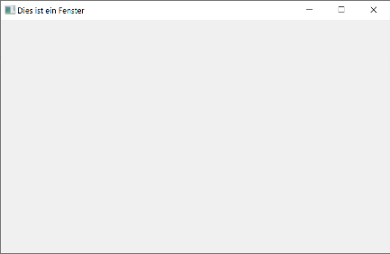

class Fenster(QMainWindow):

    def __init__(self):

        super().__init__()

        #self.setGeometry(20,120,640,480)

        self.setMinimumWidth(1280)

        self.setMinimumHeight(768)

        self.setWindowTitle("Dies ist ein Fenster")

        self.show()

app = QApplication([])

fenster = Fenster()

fenster.raise_()

app.exec()

* **01_hboxlayout.py**

from PyQt5.QtWidgets import *

class Fenster(QMainWindow):

    def __init__(self):

        super().__init__()

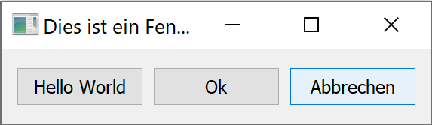

        #self.setMinimumWidth(1280)

        #self.setMinimumHeight(768)

        self.setWindowTitle("Dies ist ein Fenster")

        layout = QHBoxLayout()

        button1 = QPushButton("Hello World")

        button2 = QPushButton("Ok")

        button3 = QPushButton("Abbrechen")

        layout.addWidget(button1)

        layout.addWidget(button2)

        layout.addWidget(button3)

        center = QWidget()

        center.setLayout(layout)

        self.setCentralWidget(center)

        self.show()

app = QApplication([])

fenster = Fenster()

fenster.raise_()

app.exec()

* **02_widgets.py**

from PyQt5.QtWidgets import *

class Fenster(QMainWindow):

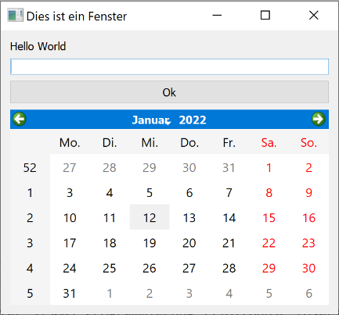    def __init__(self):

        super().__init__()

        self.setWindowTitle("Dies ist ein Fenster")

        layout = QVBoxLayout()

        label = QLabel("Hello World")

        edit = QLineEdit()

        button = QPushButton("Ok")

        calendar = QCalendarWidget()

        layout.addWidget(label)

        layout.addWidget(edit)

        layout.addWidget(button)

        layout.addWidget(calendar)

        center = QWidget()

        center.setLayout(layout)

        self.setCentralWidget(center)

        self.show()

app = QApplication([])

fenster = Fenster()

fenster.raise_()

app.exec()

* **03_gridlayout.py**

from PyQt5.QtWidgets import *

from PyQt5.QtCore import *

class Window(QMainWindow):

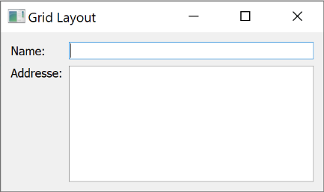    def __init__(self):

        super().__init__()

        self.setWindowTitle("Grid Layout")

        layout = QGridLayout()

        nameLabel = QLabel("Name:")

        nameLine = QLineEdit()

        addressLabel = QLabel("Addresse:")

        addressLine = QTextEdit()

        layout.addWidget(nameLabel, 0, 0)

        layout.addWidget(nameLine, 0, 1)

        layout.addWidget(addressLabel, 1, 0, Qt.AlignTop)

        layout.addWidget(addressLine, 1, 1)

        center = QWidget()

        center.setLayout(layout)

        self.setCentralWidget(center)

        self.show()

app = QApplication([])

fenster = Window()

fenster.raise_()

app.exec()

* **04_formlayout.py**

from PyQt5.QtWidgets import *

from PyQt5.QtCore import *

class Window(QMainWindow):

    def __init__(self):

        super().__init__()

        self.setWindowTitle("Grid Layout")

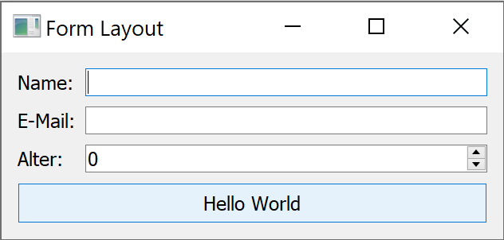        layout = QFormLayout()

        # Widgets erstellen

        name = QLineEdit()

        email = QLineEdit()

        alter = QSpinBox()

        button = QPushButton("Hello World")

        # Widgets dem Layout hinzufügen

        layout.addRow("Name:", name)

        layout.addRow("E-Mail:", email)

        layout.addRow("Alter:", alter)

        layout.addRow(button)

        center = QWidget()

        center.setLayout(layout)

        self.setCentralWidget(center)

        self.show()

app = QApplication([])

fenster = Window()

fenster.raise_()

app.exec()

* **05_multilayout.py**

from PyQt5.QtWidgets import *

from PyQt5.QtCore import *

class Window(QMainWindow):

    def __init__(self):

        super().__init__()

        self.setWindowTitle("Grid Layout")

        layout_start = QVBoxLayout()

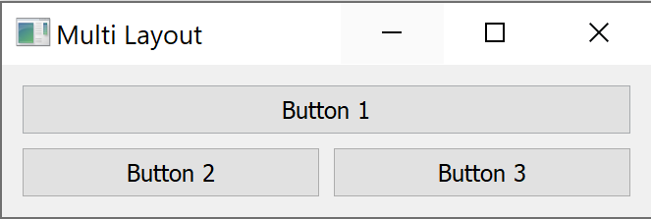        layout2 = QHBoxLayout()

        # Widgets erstellen

        button1 = QPushButton("Button 1")

        button2 = QPushButton("Button 2")

        button3 = QPushButton("Button 3")

        # Widgets dem Layout hinzufügen

        layout_start.addWidget(button1)

        layout2.addWidget(button2)

        layout2.addWidget(button3)

        layout_start.addLayout(layout2)

        center = QWidget()

        center.setLayout(layout_start)

        self.setCentralWidget(center)

        self.show()

app = QApplication([])

fenster = Window()

fenster.raise_()

app.exec()

* **06_menu.py**

from PyQt5.QtWidgets import *

from PyQt5.QtCore import *

class Window(QMainWindow):

    def __init__(self):

        super().__init__()

        self.setWindowTitle("Menu")

        menubar = self.menuBar()

        filemenu = menubar.addMenu("File")

        editmenu = menubar.addMenu("Edit")

        viewmenu = menubar.addMenu("View")

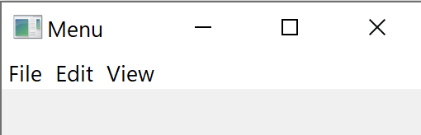

        open = QAction("Öffnen", self)

        save = QAction("Speichern", self)

        quit = QAction("Exit", self)

        quit.setMenuRole(QAction.QuitRole)

        filemenu.addAction(open)

        filemenu.addAction(save)

        filemenu.addSeparator()

        filemenu.addAction(quit)

        open.triggered.connect(self.doOpen)

        quit.triggered.connect(self.doQuit)

        self.show()

    def doOpen(self):

        print("Datei öffnen!!!")

    def doQuit(self):

        exit(0)

app = QApplication([])

fenster = Window()

fenster.raise_()

app.exec()

* **07_signal_slot.py**

from PyQt5.QtWidgets import *

from PyQt5.QtCore import *

class Window(QMainWindow):

    def __init__(self):

        super().__init__()

        self.setWindowTitle("Grid Layout")

        layout = QVBoxLayout()

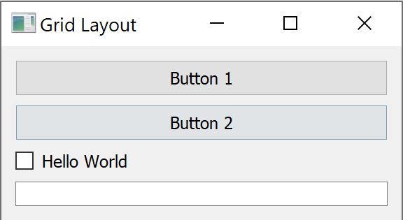

        # Widgets erstellen

        button1 = QPushButton("Button 1")

        button2 = QPushButton("Button 2")

        checkbox = QCheckBox("Hello World")

        self.name = QLineEdit()

        # Widgets dem Layout hinzufügen

        layout.addWidget(button1)

        layout.addWidget(button2)

        layout.addWidget(checkbox)

        layout.addWidget(self.name)

        center = QWidget()

        center.setLayout(layout)

        self.setCentralWidget(center)

        self.show()

        ########

        button1.clicked.connect(self.Knopf1)

        button2.clicked.connect(self.Knopf2)

        checkbox.stateChanged.connect(self.MyCheckBox)

    def MyCheckBox(self, state):

        if state == Qt.CheckState.Checked:

            print("Checkbox ist gewählt!")

        elif state == Qt.CheckState.Unchecked:

            print("Checkbox ist nicht gewählt")

    def Knopf1(self):

        print("Line Edit hat den Wert: " + self.name.text())

    def Knopf2(self):

        self.name.setText("Hello World")

app = QApplication([])

fenster = Window()

fenster.raise_()

app.exec()

# Kapitel 7 – GUI Programmierung, Teil 2

## Vorlesung

* **dialog.py**

from PyQt5.QtCore import *

from PyQt5.QtWidgets import *

class Fenster(QMainWindow):

    def __init__(self):

        super().__init__()

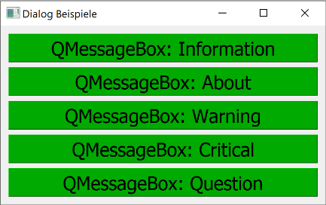

        self.setWindowTitle("Dialog Beispiele")

        layout = QVBoxLayout()

        button1 = QPushButton("QMessageBox: Information")

        button2 = QPushButton("QMessageBox: About")

        button3 = QPushButton("QMessageBox: Warning")

        button4 = QPushButton("QMessageBox: Critical")

        button5 = QPushButton("QMessageBox: Question")

        button1.clicked.connect(self.button1_clicked)

        button2.clicked.connect(self.button2_clicked)

        button3.clicked.connect(self.button3_clicked)

        button4.clicked.connect(self.button4_clicked)

        button5.clicked.connect(self.button5_clicked)

        style = """QPushButton { font-size: 48px; background-color: #00AA00; }

                   QPushButton:pressed {font-size: 48px; background-color: #AA0000}"""

        button1.setStyleSheet(style)

        button2.setStyleSheet(style)

        button3.setStyleSheet(style)

        button4.setStyleSheet(style)

        button5.setStyleSheet(style)

        layout.addWidget(button1)

        layout.addWidget(button2)

        layout.addWidget(button3)

        layout.addWidget(button4)

        layout.addWidget(button5)

        center = QWidget()

        center.setLayout(layout)

        self.setCentralWidget(center)

        self.show()

    def button1_clicked(self):

        QMessageBox.information(self, "Titel", "<h1>Hello World</h1>Python macht Spass<br/>Dies ist eine Zeile")

    def button2_clicked(self):

        QMessageBox.about(self, "Titel", "Dieses Programm wurde mit PyQT5 erstellt")

    def button3_clicked(self):

        QMessageBox.warning(self, "Titel", "Disk ist voll, das File konnte nicht geschrieben werden")

    def button4_clicked(self):

        QMessageBox.critical(self, "Stop", "Das Konfigurations-File konnte nicht geladen werden. Das Programm muss beendet werden.")

        self.close()

    def button5_clicked(self):

        antwort = QMessageBox.question(self, "Frage", "Ist Python eine gute Spache?", QMessageBox.Yes, QMessageBox.No)

        if antwort == QMessageBox.Yes:

            QMessageBox.information(self, "Python", "Ja, das ist klar")

        else:

            QMessageBox.critical(self, "Buuuuuuh!!!!", "Ok, das Programm wird beendet")

            self.close()

app = QApplication([])

f = Fenster()

app.exec()

* **dialog2.py**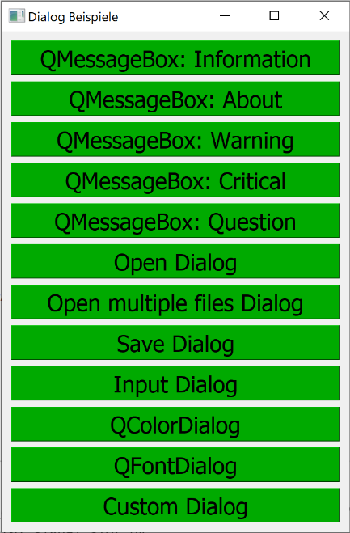

from PyQt5.QtCore import *

from PyQt5.QtWidgets import *

from PyQt5.QtGui import *

class Dialog(QDialog):

    def __init__(self, parent):

        super().__init__(parent)

        label = QLabel("Dies ist ein Label")

        button = QPushButton("Ok")

        layout = QVBoxLayout()

        layout.addWidget(label)

        layout.addWidget(button)

        self.setLayout(layout)

        button.clicked.connect(self.button_clicked)

    def button_clicked(self):

        self.close()

class Fenster(QMainWindow):

    def __init__(self):

        super().__init__()

        self.setWindowTitle("Dialog Beispiele")

        layout = QVBoxLayout()

        buttons = []

        buttons.append(QPushButton("QMessageBox: Information"))

        buttons.append(QPushButton("QMessageBox: About"))

        buttons.append(QPushButton("QMessageBox: Warning"))

        buttons.append(QPushButton("QMessageBox: Critical"))

        buttons.append(QPushButton("QMessageBox: Question"))

        buttons.append(QPushButton("Open Dialog"))

        buttons.append(QPushButton("Open multiple files Dialog"))

        buttons.append(QPushButton("Save Dialog"))

        buttons.append(QPushButton("Input Dialog"))

        buttons.append(QPushButton("QColorDialog"))

        buttons.append(QPushButton("QFontDialog"))

        buttons.append(QPushButton("Custom Dialog"))

        buttons[0].clicked.connect(self.button1_clicked)

        buttons[1].clicked.connect(self.button2_clicked)

        buttons[2].clicked.connect(self.button3_clicked)

        buttons[3].clicked.connect(self.button4_clicked)

        buttons[4].clicked.connect(self.button5_clicked)

        buttons[5].clicked.connect(self.button6_clicked)

        buttons[6].clicked.connect(self.button7_clicked)

        buttons[7].clicked.connect(self.button8_clicked)

        buttons[8].clicked.connect(self.button9_clicked)

        buttons[9].clicked.connect(self.button10_clicked)

        buttons[10].clicked.connect(self.button11_clicked)

        buttons[11].clicked.connect(self.button12_clicked)

        style = """QPushButton { font-size: 48px; background-color: #00AA00; }

                   QPushButton:pressed {font-size: 48px; background-color: #AA0000}"""

        for button in buttons:

            button.setStyleSheet(style)

            layout.addWidget(button)

        center = QWidget()

        center.setLayout(layout)

        self.setCentralWidget(center)

        self.show()

    def button1_clicked(self):

        QMessageBox.information(self, "Titel", "<h1>Hello World</h1>Python macht Spass<br/>Dies ist eine Zeile")

    def button2_clicked(self):

        QMessageBox.about(self, "Titel", "Dieses Programm wurde mit PyQT5 erstellt")

    def button3_clicked(self):

        QMessageBox.warning(self, "Titel", "Disk ist voll, das File konnte nicht geschrieben werden")

    def button4_clicked(self):

        QMessageBox.critical(self, "Stop", "Das Konfigurations-File konnte nicht geladen werden. Das Programm muss beendet werden.")

        self.close()

    def button5_clicked(self):

        antwort = QMessageBox.question(self, "Frage", "Ist Python eine gute Spache?", QMessageBox.Yes, QMessageBox.No)

        if antwort == QMessageBox.Yes:

            QMessageBox.information(self, "Python", "Ja, das ist klar")

        else:

            QMessageBox.critical(self, "Buuuuuuh!!!!", "Ok, das Programm wird beendet")

            self.close()

    def button6_clicked(self):

        dateifilter = "Textdatei (*.txt *.ttt);;Python File (*.py)"

        path = QStandardPaths.standardLocations(QStandardPaths.DesktopLocation)[0]

        filename, filter = QFileDialog.getOpenFileName(self, "Datei öffnen", path, dateifilter)

        if filename != "":

            QMessageBox.information(self, "File", f"<h1>{filename}</h1><h2>{filter}</h2>")

        else:

            QMessageBox.warning(self, "Kein File", "Es wurde kein File ausgewählt")

    def button7_clicked(self):

        filenamen, filter = QFileDialog.getOpenFileNames(self, "Dateien öffnen", "", "Text (*.txt)")

        print(filenamen)

    def button8_clicked(self):

        filename, filter = QFileDialog.getSaveFileName(self, "Speichern", "", "Python (*.py)")

        print(filename, filter)

    def button9_clicked(self):

        wert, ok = QInputDialog.getItem(self, "Auswahl", "Welches Land ist schöner ?", ["Schweiz", "Deutschland", "Österreich"], 1, True)

        wert, ok = QInputDialog.getDouble(self, "Titel", "Text")

        wert, ok = QInputDialog.getInt(self, "Titel", "Text", 20, 10, 30)

        if ok:

            print(wert)

    def button10_clicked(self):

        farbe = QColorDialog.getColor(initial=QColor(0,0,255))

        print(farbe.red(), farbe.green(), farbe.blue())

    def button11_clicked(self):

        font = QFontDialog.getFont()

    def button12_clicked(self):

        d = Dialog(self)

        d.exec()

app = QApplication([])

f = Fenster()

app.exec()

* **dialog3.py**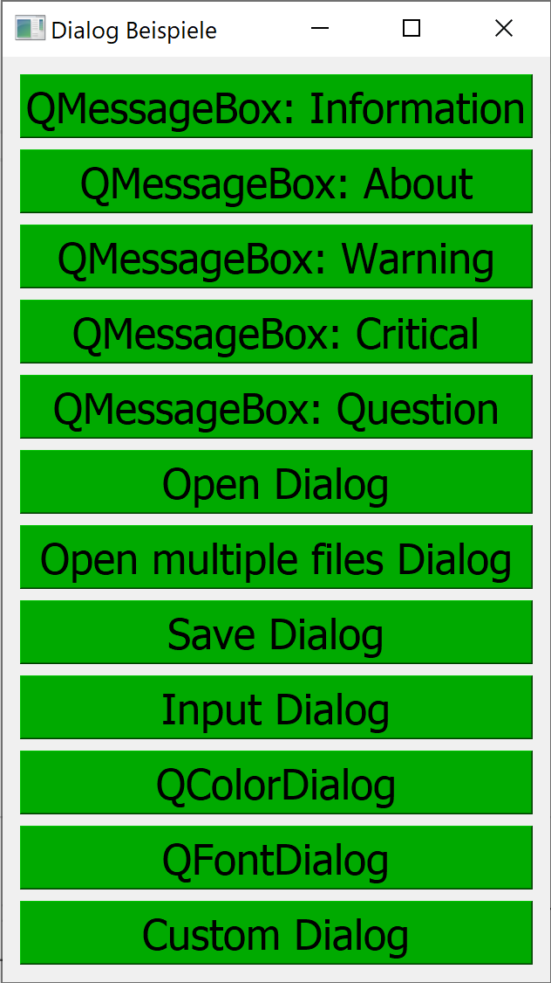

from PyQt5.QtCore import *

from PyQt5.QtWidgets import *

from PyQt5.QtGui import *

style = """* {font-size: 48px;}

                    QPushButton { font-size: 48px; background-color: #00AA00; }

                   QPushButton:pressed {font-size: 48px; background-color: #AA0000}"""

class Dialog(QDialog):

    def __init__(self, parent):

        super().__init__(parent)

        label = QLabel("Dies ist ein Label")

        button = QPushButton("Ok")

        layout = QVBoxLayout()

        layout.addWidget(label)

        layout.addWidget(button)

        self.setLayout(layout)

        self.setStyleSheet(style)

        button.clicked.connect(self.button_clicked)

    def button_clicked(self):

        self.close()

#---------------------------------------------------------------------------------------

class Fenster(QMainWindow):

    def __init__(self):

        super().__init__()

        self.setWindowTitle("Dialog Beispiele")

        layout = QVBoxLayout()

        buttons = []

        buttons.append(QPushButton("QMessageBox: Information"))

        buttons.append(QPushButton("QMessageBox: About"))

        buttons.append(QPushButton("QMessageBox: Warning"))

        buttons.append(QPushButton("QMessageBox: Critical"))

        buttons.append(QPushButton("QMessageBox: Question"))

        buttons.append(QPushButton("Open Dialog"))

        buttons.append(QPushButton("Open multiple files Dialog"))

        buttons.append(QPushButton("Save Dialog"))

        buttons.append(QPushButton("Input Dialog"))

        buttons.append(QPushButton("QColorDialog"))

        buttons.append(QPushButton("QFontDialog"))

        buttons.append(QPushButton("Custom Dialog"))

        # Mit getattr kann die Mathode in der Klasse direkt gesucht werden (Advanced)

        # Man könnte sich auch die untere for-Schleife sparen und alles in eine for-Schleife packen

        for i in range(0,len(buttons)):

            function = getattr(self,f"button{i+1}_clicked")

            buttons[i].clicked.connect(function)

        for button in buttons:

            button.setStyleSheet(style)

            layout.addWidget(button)

        center = QWidget()

        center.setLayout(layout)

        self.setCentralWidget(center)

        self.show()

    def button1_clicked(self):

        QMessageBox.information(self, "Titel", "<h1>Hello World</h1>Python macht Spass<br/>Dies ist eine Zeile")

    def button2_clicked(self):

        QMessageBox.about(self, "Titel", "Dieses Programm wurde mit PyQT5 erstellt")

    def button3_clicked(self):

        QMessageBox.warning(self, "Titel", "Disk ist voll, das File konnte nicht geschrieben werden")

    def button4_clicked(self):

        QMessageBox.critical(self, "Stop", "Das Konfigurations-File konnte nicht geladen werden. Das Programm muss beendet werden.")

        self.close()

    def button5_clicked(self):

        antwort = QMessageBox.question(self, "Frage", "Ist Python eine gute Spache?", QMessageBox.Yes, QMessageBox.No)

        if antwort == QMessageBox.Yes:

            QMessageBox.information(self, "Python", "Ja, das ist klar")

        else:

            QMessageBox.critical(self, "Buuuuuuh!!!!", "Ok, das Programm wird beendet")

            self.close()

    def button6_clicked(self):

        dateifilter = "Textdatei (*.txt *.ttt);;Python File (*.py)"

        path = QStandardPaths.standardLocations(QStandardPaths.DesktopLocation)[0]

        filename, filter = QFileDialog.getOpenFileName(self, "Datei öffnen", path, dateifilter)

        if filename != "":

            QMessageBox.information(self, "File", f"<h1>{filename}</h1><h2>{filter}</h2>")

        else:

            QMessageBox.warning(self, "Kein File", "Es wurde kein File ausgewählt")

    def button7_clicked(self):

        filenamen, filter = QFileDialog.getOpenFileNames(self, "Dateien öffnen", "", "Text (*.txt)")

        print(filenamen)

    def button8_clicked(self):

        filename, filter = QFileDialog.getSaveFileName(self, "Speichern", "", "Python (*.py)")

        print(filename, filter)

    def button9_clicked(self):

        wert, ok = QInputDialog.getItem(self, "Auswahl", "Welches Land ist schöner ?", ["Schweiz", "Deutschland", "Österreich"], 1, True)

        wert, ok = QInputDialog.getDouble(self, "Titel", "Text")

        wert, ok = QInputDialog.getInt(self, "Titel", "Text", 20, 10, 30)

        if ok:

            print(wert)

    def button10_clicked(self):

        farbe = QColorDialog.getColor(initial=QColor(0,0,255))

        print(farbe.red(), farbe.green(), farbe.blue())

    def button11_clicked(self):

        font = QFontDialog.getFont()

    def button12_clicked(self):

        d = Dialog(self)

        d.exec()

app = QApplication([])

f = Fenster()

app.exec()

# Kapitel 8 – GUI Programmierung: QtDesigner

## Vorlesung

* 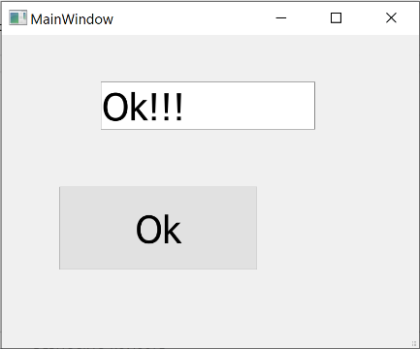**mygui.py**

from PyQt5.QtWidgets import *

from PyQt5.uic import *

def hello():

    print("Button wurde geklicked!")

    fenster.lineEdit.setText("Ok!!!")

app = QApplication([])

fenster = loadUi("Kapitel_08/gui.ui")

fenster.show()

fenster.meinSuperButton.clicked.connect(hello)

app.exec()

* **mygui2.py** 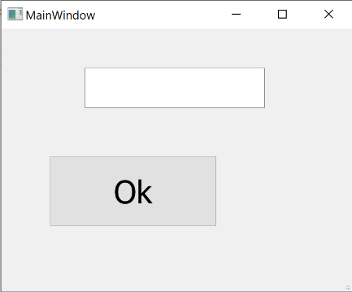

from PyQt5.QtCore import *

from PyQt5.QtWidgets import *

from PyQt5.uic import *

class MeinFenster(QMainWindow):

    def __init__(self):

        super().__init__()

        loadUi("Vorlesung_Files von Christen/Kapitel_08/gui.ui", self)

        self.meinSuperButton.clicked.connect(self.button_click)

        self.show()

    def button_click(self):

        print("Hello")

app = QApplication([])

fenster = MeinFenster()

app.exec()

* **mygui3.py** 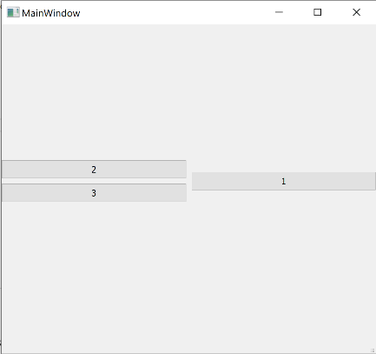

from PyQt5.QtCore import *

from PyQt5.QtWidgets import *

from PyQt5.uic import *

class MeinFenster(QMainWindow):

    def __init__(self):

        super().__init__()

        loadUi("Vorlesung_Files von Christen/Kapitel_08/gui2.ui", self)

        self.button1.clicked.connect(self.button1_click)

        self.show()

    def button1_click(self):

        print("Hello")

app = QApplication([])

fenster = MeinFenster()

app.exec()

* **umrechner.py** 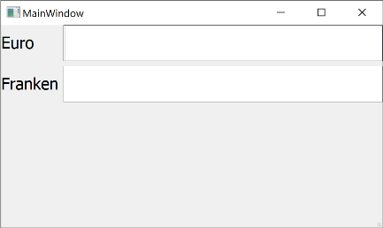

from PyQt5.QtCore import *

from PyQt5.QtWidgets import *

from PyQt5.uic import *

class Umrechner(QMainWindow):

    def __init__(self):

        super().__init__()

        loadUi("Vorlesung_Files von Christen/Kapitel_08/gui3.ui", self)

        self.createConnects()

        self.show()

    # -------------------------------------------------------------------------

    def createConnects(self):

        #self.umrechnen.clicked.connect(self.buttonUmrechnen)

        self.euroLineEdit.textChanged.connect(self.euroEdit)

    # -------------------------------------------------------------------------

    def euroEdit(self, text):

        self.buttonUmrechnen()

    def buttonUmrechnen(self):

        euro = self.euroLineEdit.text()

        try:

            wert = float(euro)

            wert_chf = wert * 1.06

            self.frankenLineEdit.setText(str(wert_chf))

        except:

            self.frankenLineEdit.setText("ungültiger Wert")

app = QApplication([])

fenster = Umrechner()

app.exec()

* **webbrowser.py**

from PyQt5.QtCore import *

from PyQt5.QtWidgets import *

from PyQt5.QtWebEngineWidgets import *

from PyQt5.uic import *

class Browser(QMainWindow):

    def __init__(self):

        super().__init__()

        loadUi("Vorlesung_Files von Christen/Kapitel_08/webbrowser.ui", self)

        # Cookies erlauben

        defaultProfile = QWebEngineProfile.defaultProfile()

        defaultProfile.setPersistentCookiesPolicy(QWebEngineProfile.ForcePersistentCookies)

        self.show()

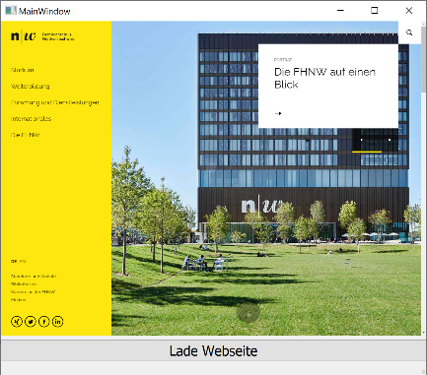

        self.pushButton.clicked.connect(self.loadPage)

    def loadPage(self):

        htmlcode = """

        <h1>Hello World</h1>

        Dies ist eine Website<br/>

        Bla bla bla

        """

        #self.webEngineView.setHtml(htmlcode)

        self.webEngineView.load(QUrl("https://www.fhnw.ch"))

app = QApplication([])

fenster = Browser()

app.exec()

# Kapitel 9 – Matplotlib & Qt

## Vorlesung

**KEINE**

# Kapitel 10 – Projektionen und Vektordaten, Teil 1: Shapely

## Vorlesung

* 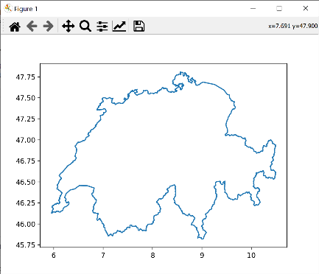**geometrie.py**

from shapely.geometry import Point

import shapely.wkt

import matplotlib.pyplot as plt

FHNW = Point([47.534862756727605, 7.641589461536574])

BSL = Point([47.598829, 7.529104])

file = open("Meine File-Lessons/Kapitel_10/schweiz.wkt")

schweiz_zeichenkette = file.read()

file.close()

schweiz = shapely.wkt.loads(schweiz_zeichenkette)

for geometry in schweiz.geoms:

    x,y = geometry.exterior.xy

    plt.plot(x,y)

plt.show()

* **geometrie2.py**

from shapely.geometry import Point

import shapely.wkt

import matplotlib.pyplot as plt

FHNW = Point([7.641589461536574, 47.534862756727605])

BSL = Point([7.529104, 47.598829])

file = open("Meine File-Lessons/Kapitel_10/schweiz.wkt")

schweiz_zeichenkette = file.read()

file.close()

schweiz = shapely.wkt.loads(schweiz_zeichenkette)

if FHNW.within(schweiz):

    print("Die FHNW ist in der Schweiz.") ------------- Output ------------------> Die FHNW ist in der Schweiz.

if not BSL.within(schweiz):

    print("Starbucks am Basel Airport ist ausserhalb er Schweiz.") -------- Output -------------> Starbucks am Basel  
 Airport ist ausserhalb er Schweiz.

* **geometrie3.py**

from shapely.geometry import Point

import shapely.wkt

import matplotlib.pyplot as plt

wkt1 = "POLYGON (( -5 -5, 5 -5, 5 5, -5 5, -5 -5))"

wkt2 = "POLYGON ((1 -1, 4 -1, 4 1, 1 1, 1 4, -1 4, -1 1, -4 1, -4 -1, -1 -1, -1 -4, 1 -4, 1 -1))"

quadrat = shapely.wkt.loads(wkt1)

kreuz = shapely.wkt.loads(wkt2)

if kreuz.within(quadrat):

    print("Alles OK")

x1,y1 = quadrat.exterior.xy

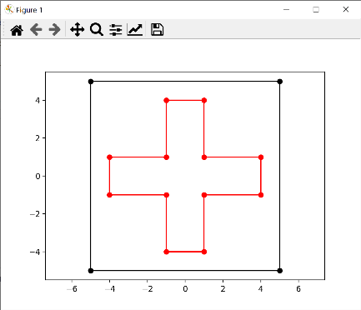x2,y2 = kreuz.exterior.xy

plt.plot(x1,y1, "ko-")

plt.plot(x2,y2, "ro-")

plt.axis("equal")

plt.show()

kreuzquadrat = kreuz.union(quadrat)

print(kreuzquadrat.wkt)

s2 = kreuz.intersection(quadrat)

s3 = kreuz.symmetric_difference(quadrat)

print(s3.wkt)

# plt.plt(x3,y3, "go-")

* **postleitzahlen.py**

from pyproj import Transformer

transformer = Transformer.from_crs('EPSG:2056', 'EPSG:4326')

t = Transformer.from_crs('EPSG:2056', 'EPSG:4326')

file = open("Meine File-Lessons/Kapitel_10/PLZO_CSV_LV95.csv", encoding="utf-8")

next(file)

# Ortsname; PLZ; Zusatzziffer; Gemeindename; BFS-Nr; Kantonskürzel; E; N; Sprache

Output:

Caviano (46.10716783267641, 8.76636015545509)

Piazzogna (46.1351214949252, 8.824928452154456)

Contone (46.14806740373982, 8.928681091984423)

Corippo (46.235765959714406, 8.840927326223506)

Vogorno (46.2226255892587, 8.85864040656365)

Lavertezzo (46.257208366193076, 8.835991748691933)

Brione (Verzasca) (46.29676823555998, 8.790302638961945)

Gerra (Verzasca) (46.31890735350791, 8.798422685674254)

Frasco (46.3402289193318, 8.802104599441554)

Sonogno (46.349825819278266, 8.786155280271315)

Aigle (46.317281532455375, 6.967618108130719)

…

…

…

for data in file:

    data =data.rstrip().split(";")

    name = data[0]

    E = float(data[6])

    N = float(data[7])

    resultat = t.transform(E,N)

    print(name, resultat)

* **transformation.py**

from pyproj import Transformer

t84 = Transformer.from_crs('EPSG:2056', 'EPSG:4326')

t95 = Transformer.from_crs('EPSG:4326', 'EPSG:2056')

"""

EPSG: 4326          Geografisches WGS84 (3D)

EPSG: 3857          Web-Mapping Mercator (z.B. Google Maps)

EPSG: 21781         CH1903/LV03

EPSG: 2056          CH1903r/LV95

"""

URL = "www.epsg.io"

resultat1 = t84.transform(2_600_000, 1_200_000)  #  _  Underscore kann bei Zahlen zur besseren lesbarkeit verwendet werden.

resultat2 = t95.transform(46.95108277187109, 7.43863242087181)

test = resultat1[0]

print(type(test))

#print(resultat1[0])

#print(resultat2)

# Kapitel 11 – Folium & GeoPandas

# Kapitel 12 – Projektionen & Vektordaten, Teil 2: cartopy

## Vorlesung

* Winkeltreue (konforme) Projektionen
  + z.B: Mercator Projektion
* Flächentreue (äquivalente) Projektionen
  + z.B: Mollweide, Wagner VII
* Vermittelnde (aphylaktische) Projektionen
  + z.B: Robinson Projektion
* Längentreue (äquidistante) Projektionen
  + z.B: Mittabstandtreue Azimutalprojektion

import cartopy.crs as ccrs

import matplotlib.pyplot as plt

ax = plt.axes(projection=ccrs.PlateCarree())

ax.coastlines()

plt.show()

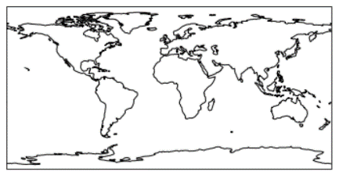

import cartopy.crs as ccrs

import matplotlib.pyplot as plt

ax = plt.axes(projection=ccrs.PlateCarree())

ax.coastlines()

ax.stock_img()

plt.show()

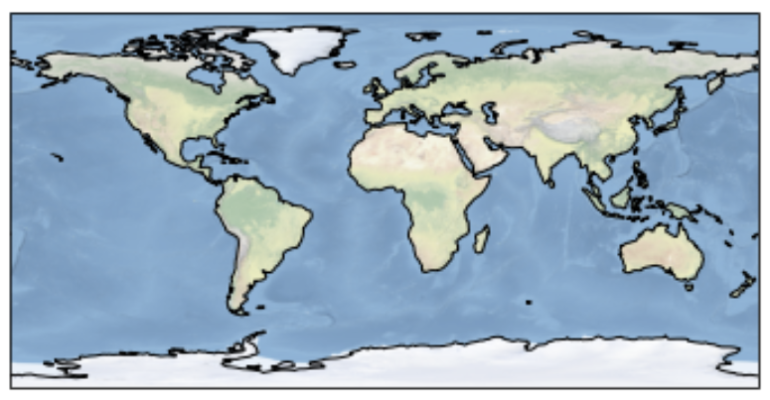

ax = plt.axes(projection=ccrs.Mollweide())

ax.coastlines()

plt.show()

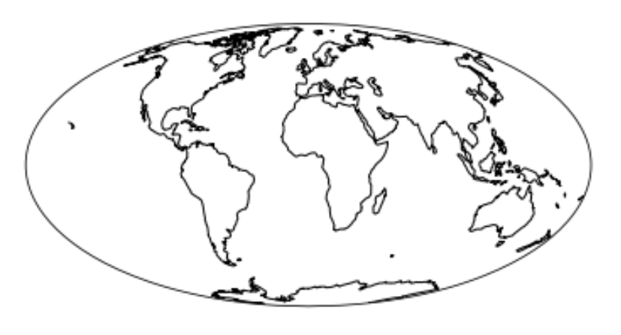

**Features der Standardkarte einblenden**

Beim ersten Aufruf werden die Daten heruntergeladen. Die "Warnung" kann ignoriert werden

import cartopy.feature as cfeature

plt.figure(figsize=(15, 9))

ax = plt.axes(projection=ccrs.PlateCarree())

ax.add_feature(cfeature.LAND, color="white")

ax.add_feature(cfeature.OCEAN, color="#006994")

ax.add_feature(cfeature.COASTLINE)

ax.add_feature(cfeature.BORDERS, linestyle=':')  #

ax.add_feature(cfeature.LAKES, alpha=0.5, color="blue")

ax.add_feature(cfeature.RIVERS)

plt.show()

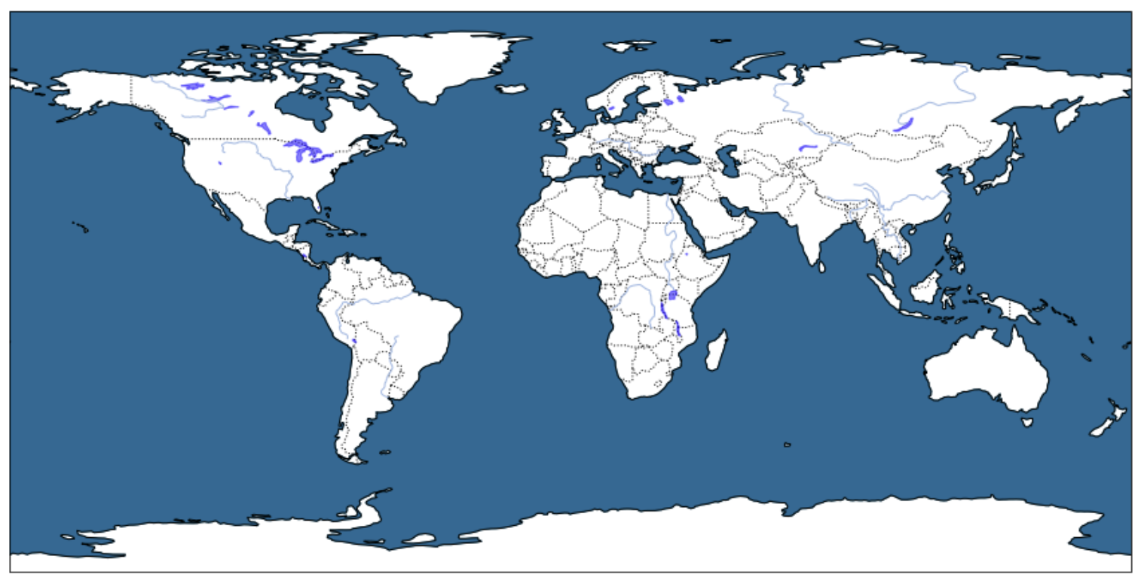

**Tissot Indikatrix**

import cartopy.feature as cfeature

import numpy as np

plt.figure(figsize=(15, 9))

ax = plt.axes(projection=ccrs.Orthographic(central_longitude=0.0, central_latitude=45.0))

ax.stock_img()

ax.coastlines()

lons = np.linspace(-180,180,15)

lats = np.linspace(-90,90,20)

ax.tissot(facecolor='red', alpha=0.5, rad_km=300, lons=lons, lats=lats)

plt.show()

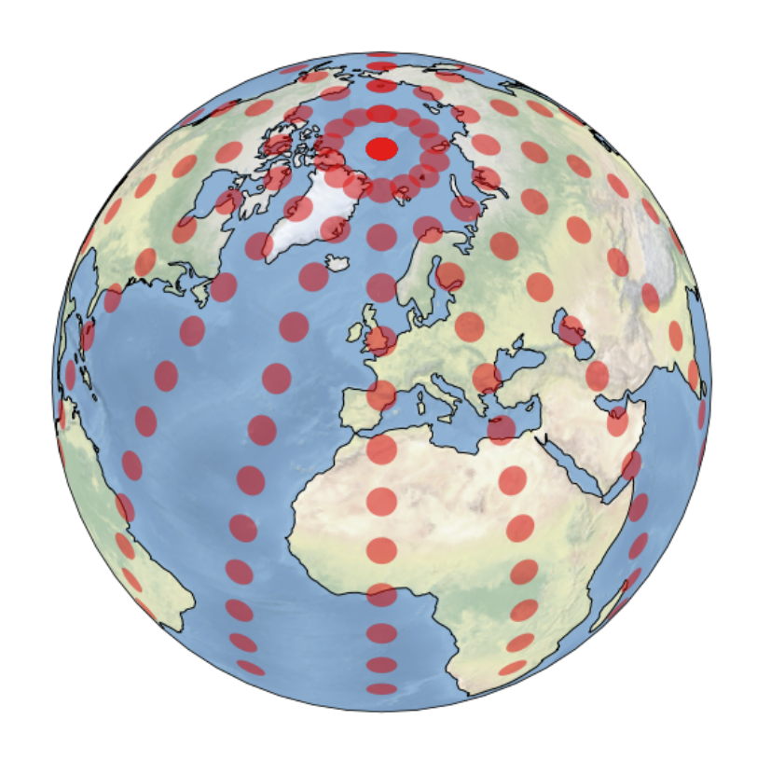

plt.figure(figsize=(15, 9))

ax = plt.axes(projection=ccrs.PlateCarree())

ax.set_global()

ax.stock_img()

ax.coastlines()

ax.tissot(facecolor='red', alpha=0.5)

plt.show()

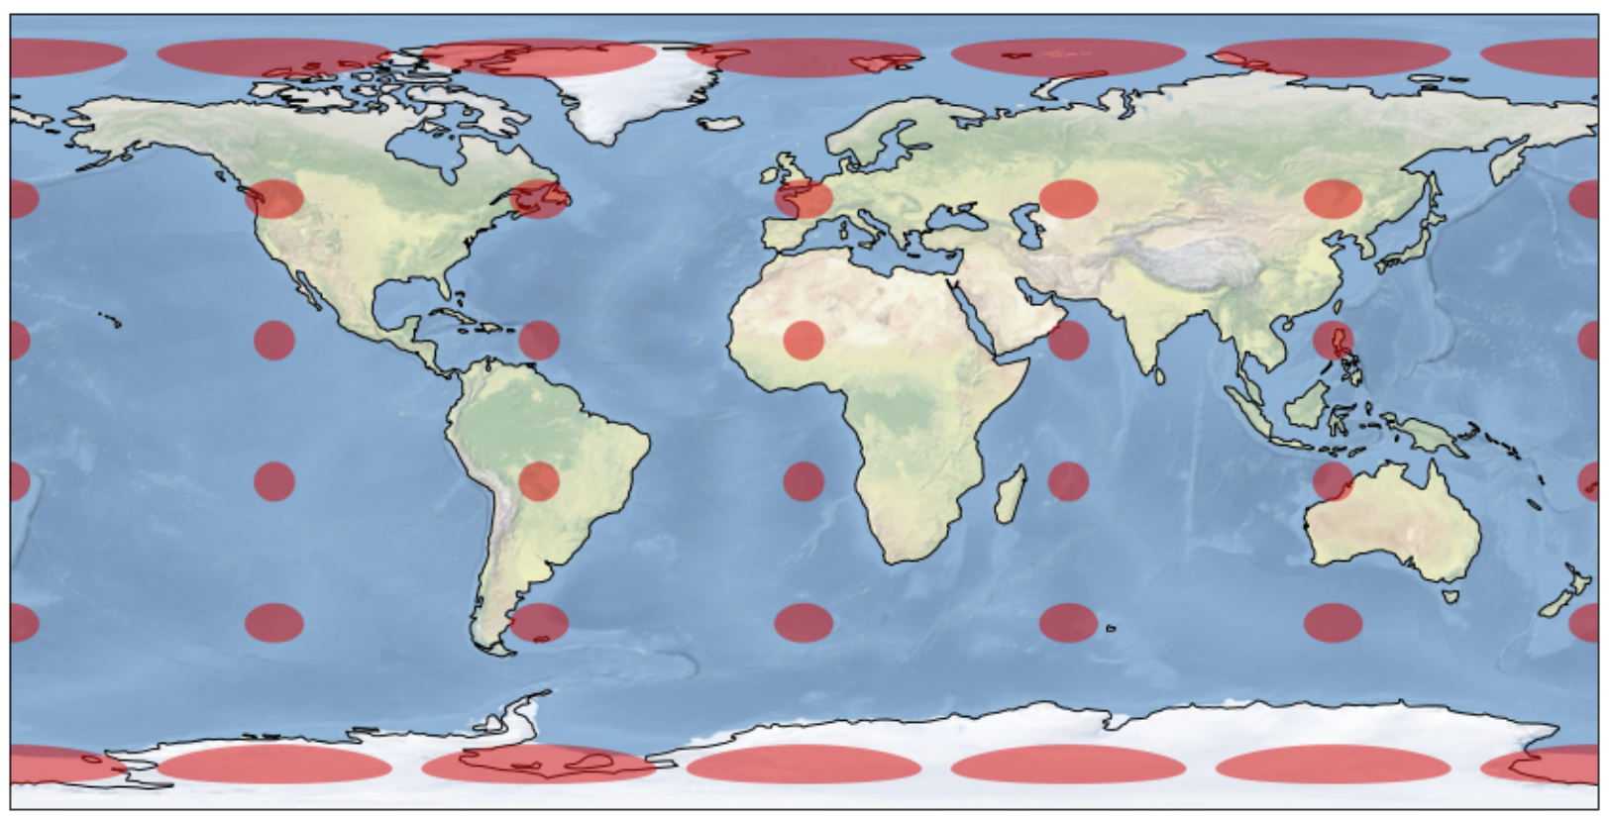

plt.figure(figsize=(15, 9))

ax = plt.axes(projection=ccrs.AlbersEqualArea())

ax.stock_img()

ax.coastlines()

ax.gridlines()

ax.tissot(facecolor='red', alpha=0.5)

plt.show()

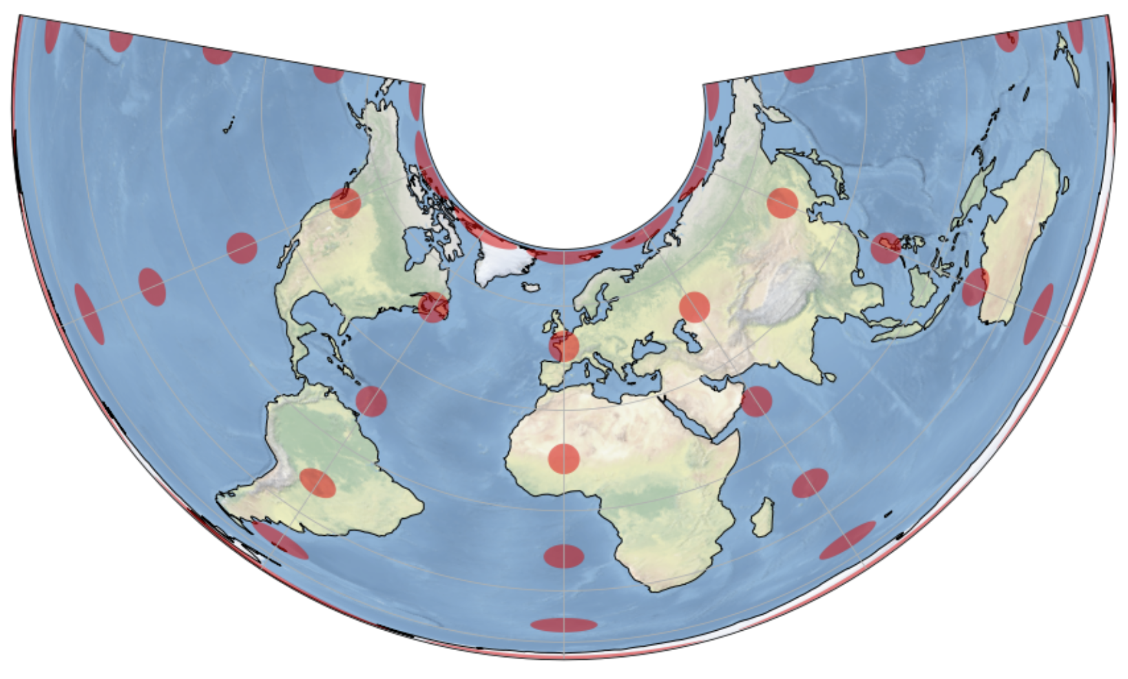

plt.figure(figsize=(15, 9))

ax = plt.axes(projection=ccrs.Mollweide())

ax.stock_img()

ax.coastlines()

ax.gridlines()

ax.tissot(facecolor='red', alpha=0.5)

plt.show();

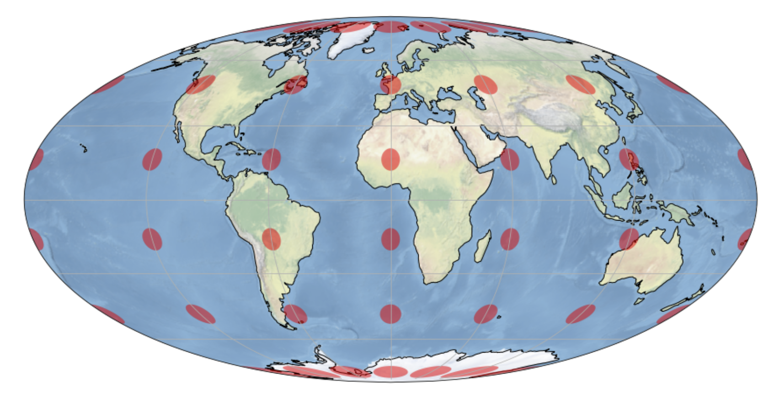

plt.figure(figsize=(15, 9))

ax = plt.axes(projection=ccrs.AzimuthalEquidistant(central_latitude=90))

ax.stock_img()

ax.coastlines()

ax.gridlines()

ax.tissot(facecolor='red', alpha=0.5)

plt.show();

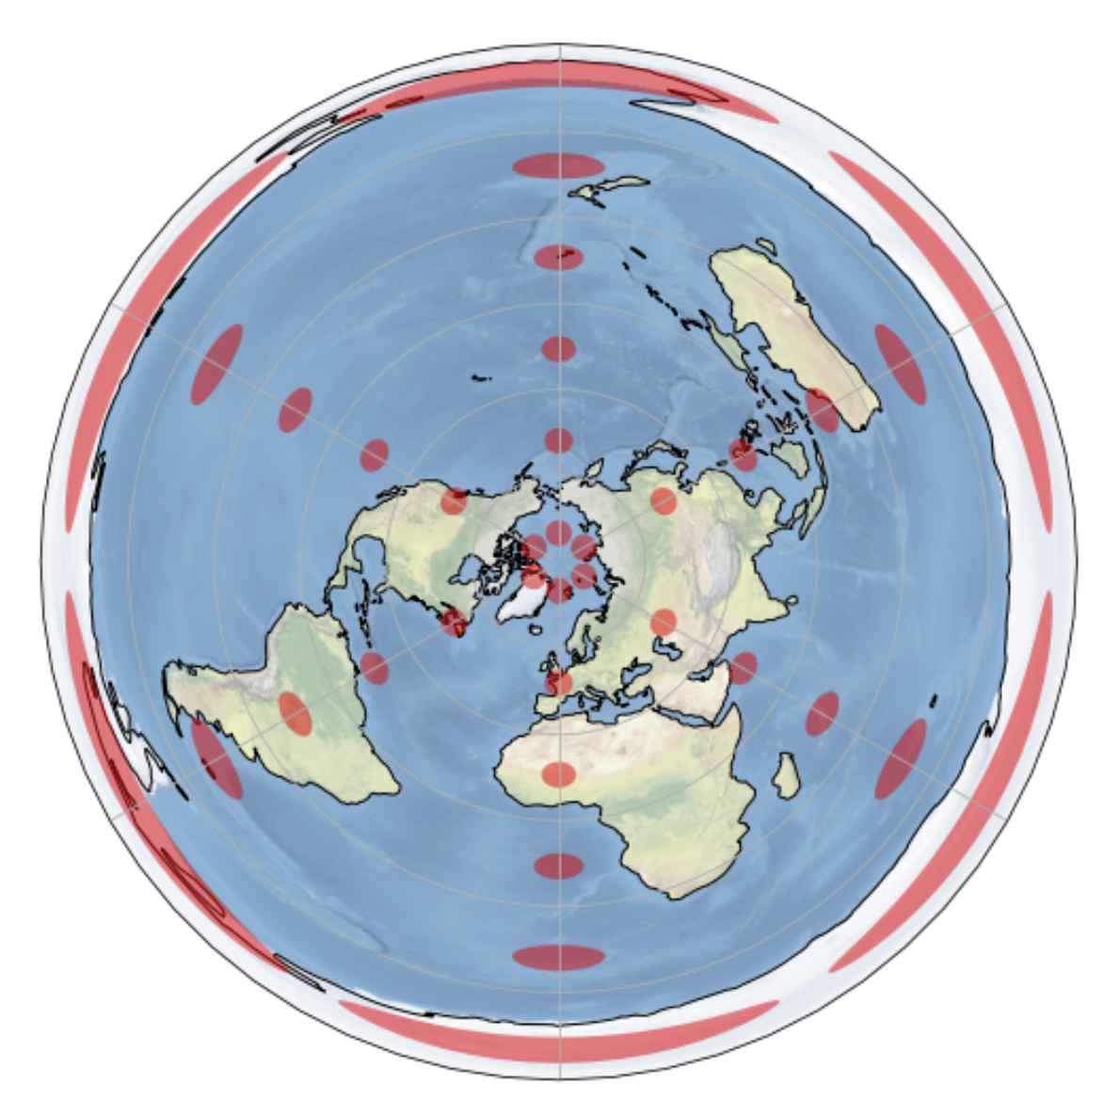

plt.figure(figsize=(15, 9))

ax = plt.axes(projection=ccrs.Mercator(min_latitude=-85.0, max_latitude=85.0))

ax.stock_img()

ax.coastlines()

ax.gridlines()

ax.tissot(facecolor='red', alpha=0.5)

plt.show();

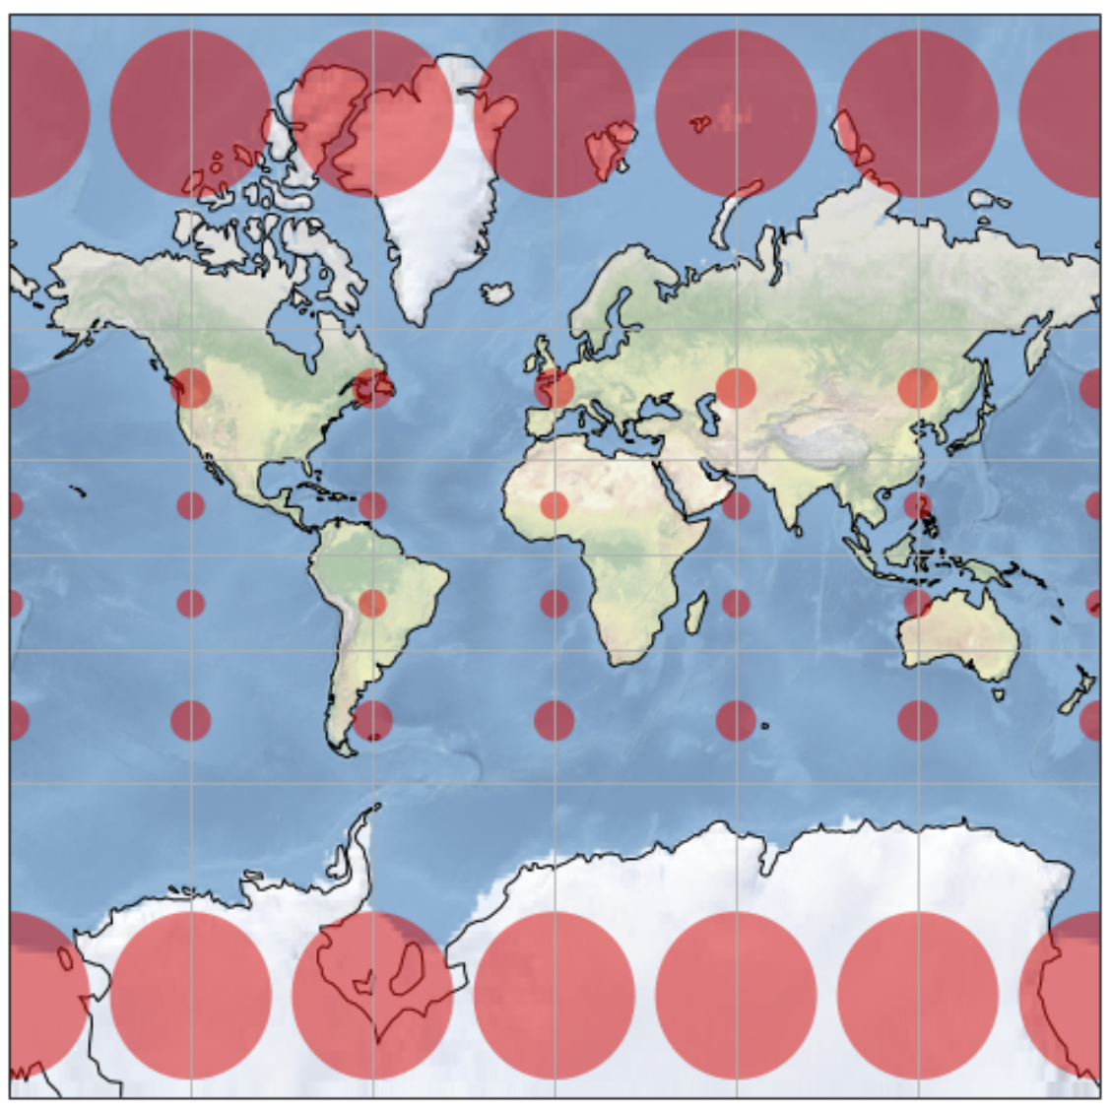

**Zeichnen auf der Karte**

plt.figure(figsize=(15, 9))

ax = plt.axes(projection=ccrs.PlateCarree())

ax.stock_img()

latMuttenz, lngMuttenz = 47.534833023418976, 7.6418778566047125

latNewYork, lngNewYork = 40.68925850566851, -74.04453971488435

plt.text(lngNewYork-2, latNewYork-2, 'New York', horizontalalignment='right', transform=ccrs.PlateCarree())

plt.text(lngMuttenz+20, latMuttenz-2, 'Muttenz', horizontalalignment='right', transform=ccrs.PlateCarree())

plt.plot([lngMuttenz, lngNewYork], [latMuttenz, latNewYork], color='red', linewidth=2, marker='o', transform=ccrs.PlateCarree())

plt.show()

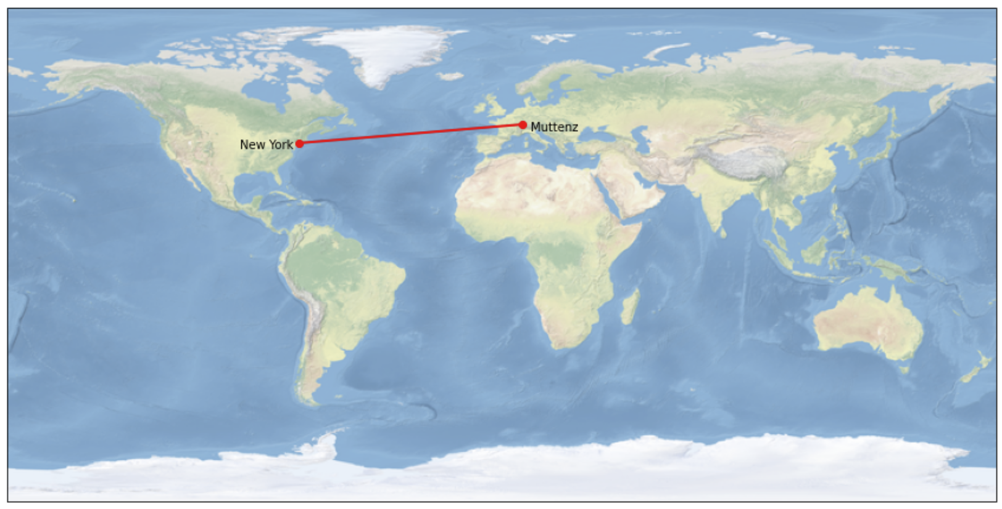

**Transformation: Geodätisch**

plt.figure(figsize=(15, 9))

ax = plt.axes(projection=ccrs.PlateCarree())

ax.stock_img()

latMuttenz, lngMuttenz = 47.534833023418976, 7.6418778566047125

latNewYork, lngNewYork = 40.68925850566851, -74.04453971488435

plt.text(lngNewYork-2, latNewYork-2, 'New York', horizontalalignment='right', transform=ccrs.Geodetic())

plt.text(lngMuttenz+20, latMuttenz-2, 'Muttenz', horizontalalignment='right', transform=ccrs.Geodetic())

plt.plot([lngMuttenz, lngNewYork], [latMuttenz, latNewYork], color='red', linewidth=2, marker='o', transform=ccrs.Geodetic())

plt.show()

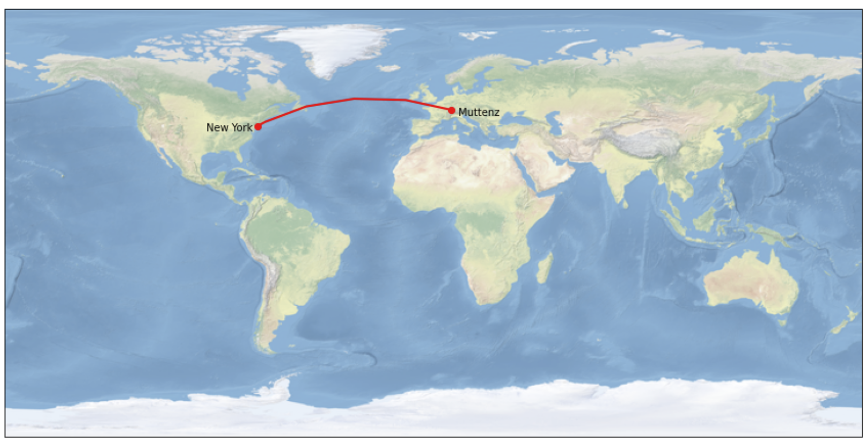

**Geodätische Linie mit pyproj berechnen**

import pyproj

import numpy as np

g = pyproj.Geod(ellps='WGS84')

latMuttenz, lngMuttenz = 47.534833023418976, 7.6418778566047125

latNewYork, lngNewYork = 40.68925850566851, -74.04453971488435

lnglat = g.npts(lngMuttenz,latMuttenz, lngNewYork, latNewYork, 20)

# erster und letzter Punkt hinzufügen

lnglat = np.array([(lngMuttenz, latMuttenz)] + lnglat +  [(lngNewYork, latNewYork)], dtype=np.float64)

print(lnglat)

[[ 7.64187786 47.53483302]  
 [ 3.9840946 48.63946998]  
 [ 0.1722679 49.62276528]  
 [ -3.78543206 50.47548158]  
 [ -7.8759829 51.18886098]  
 [-12.08129479 51.75498435]  
 [-16.37837788 52.16714725]  
 [-20.73996119 52.42021733]  
 [-25.13556591 52.51093269]  
 [-29.53295367 52.43810289]  
 [-33.8997926 52.20268456]  
 [-38.20533514 51.80772053]  
 [-42.42189904 51.25815147]  
 [-46.52598714 50.56052642]  
 [-50.49895725 49.72264985]  
 [-54.32723661 48.75320589]  
 [-58.0021438 47.66139578]  
 [-61.51942119 46.45661528]  
 [-64.87859239 45.14818767]  
 [-68.08224822 43.74515819]  
 [-71.13534094 42.25614766]  
 [-74.04453971 40.68925851]]

lng = lnglat[:,0]

lat = lnglat[:,1]

print(lng)

print(lat)

[ 7.64187786 3.9840946 0.1722679 -3.78543206 -7.8759829  
 -12.08129479 -16.37837788 -20.73996119 -25.13556591 -29.53295367  
 -33.8997926 -38.20533514 -42.42189904 -46.52598714 -50.49895725  
 -54.32723661 -58.0021438 -61.51942119 -64.87859239 -68.08224822  
 -71.13534094 -74.04453971]

[47.53483302 48.63946998 49.62276528 50.47548158 51.18886098 51.75498435  
 52.16714725 52.42021733 52.51093269 52.43810289 52.20268456 51.80772053  
 51.25815147 50.56052642 49.72264985 48.75320589 47.66139578 46.45661528  
 45.14818767 43.74515819 42.25614766 40.68925851]

**Karte mit geodätischer Linie aus pyproj zeichnen**

plt.figure(figsize=(15, 9))

ax = plt.axes(projection=ccrs.PlateCarree())

ax.stock_img()

plt.plot(lng, lat, 'r-', linewidth=2)  # 'ro-' für einzelne Punkte

plt.show()

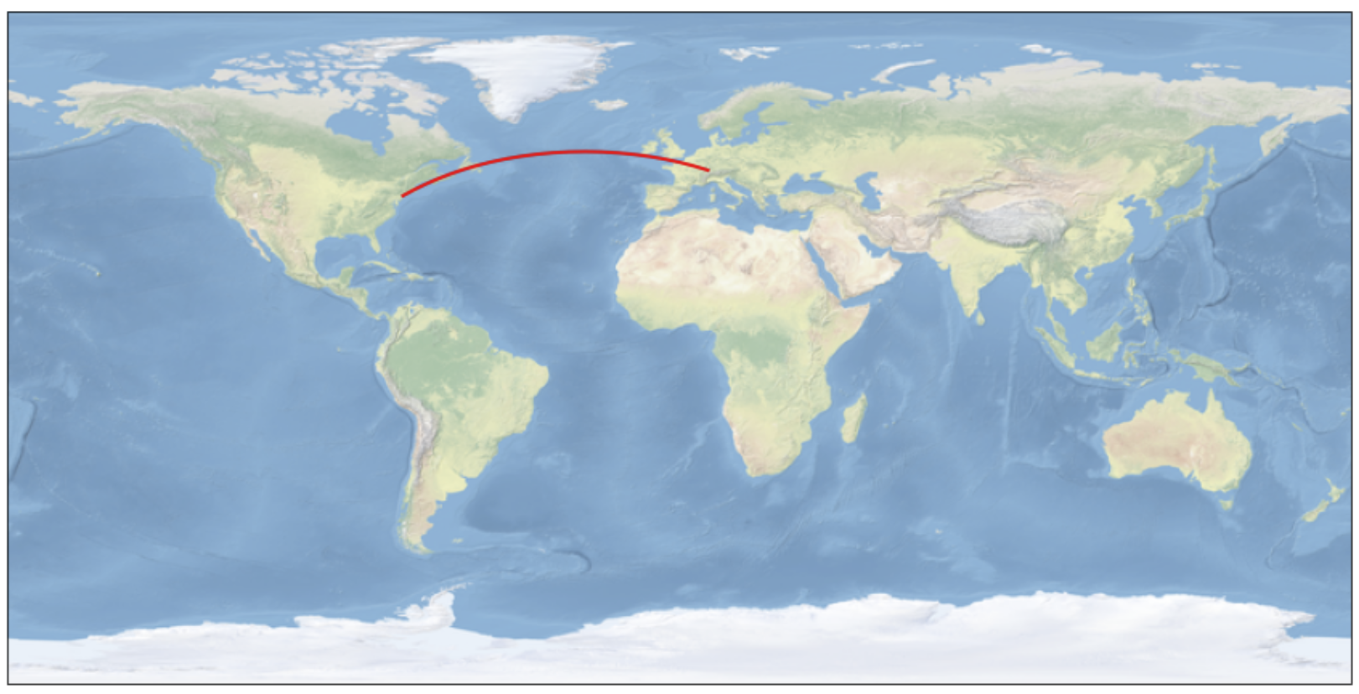

plt.figure(figsize=(15, 9))

ax = plt.axes(projection=ccrs.PlateCarree())

ax.coastlines()

ax.set_global()

plt.plot(lng, lat, 'r-', linewidth=2)  # 'ro-' für einzelne Punkte

plt.show()

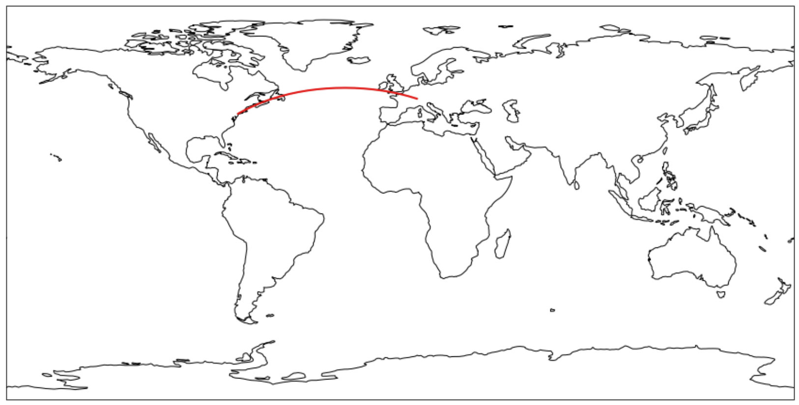

plt.figure(figsize=(15, 9))

ax = plt.axes(projection=ccrs.Mollweide())

ax.stock_img()

ax.gridlines(color="#555555")

plt.plot(lng, lat, 'r-', linewidth=2, transform=ccrs.Geodetic())

plt.show()

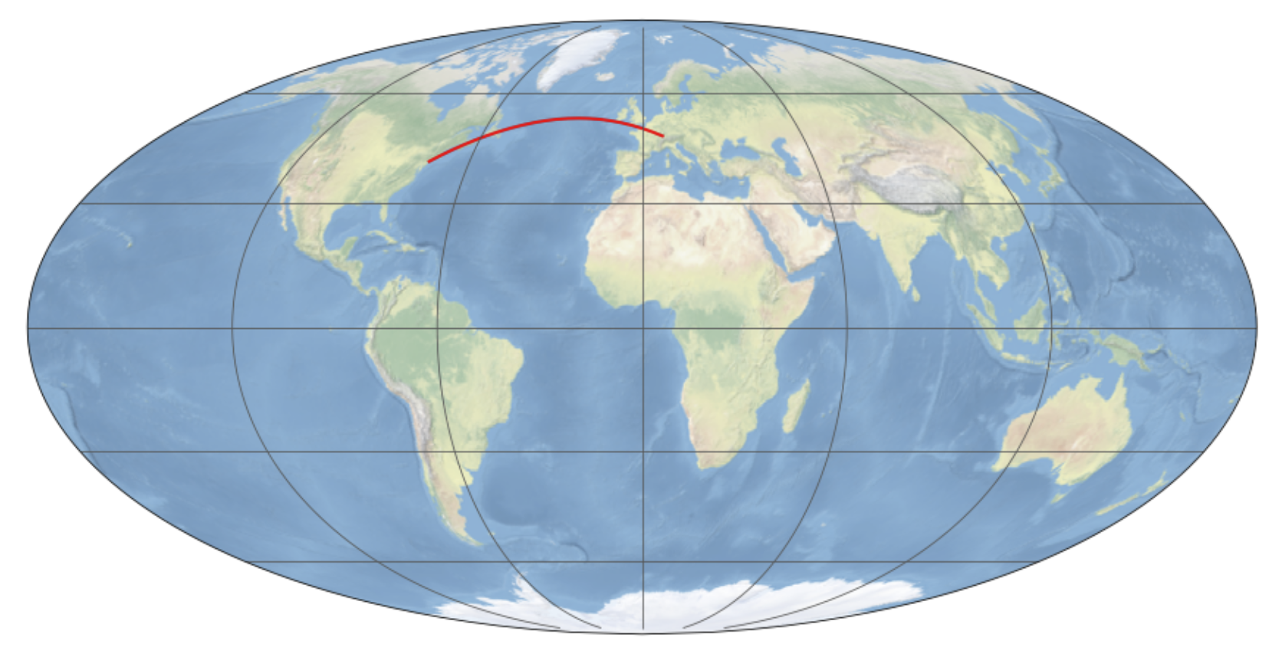

plt.figure(figsize=(15, 9))

ax = plt.axes(projection=ccrs.Robinson())

ax.stock_img()

ax.gridlines(color="#555555")

plt.text(lngNewYork-2, latNewYork-2, 'New York', horizontalalignment='right', transform=ccrs.Geodetic())

plt.text(lngMuttenz+20, latMuttenz-2, 'Muttenz', horizontalalignment='right', transform=ccrs.Geodetic())

plt.plot(lng, lat, 'r-', linewidth=2, transform=ccrs.Geodetic())

plt.show()

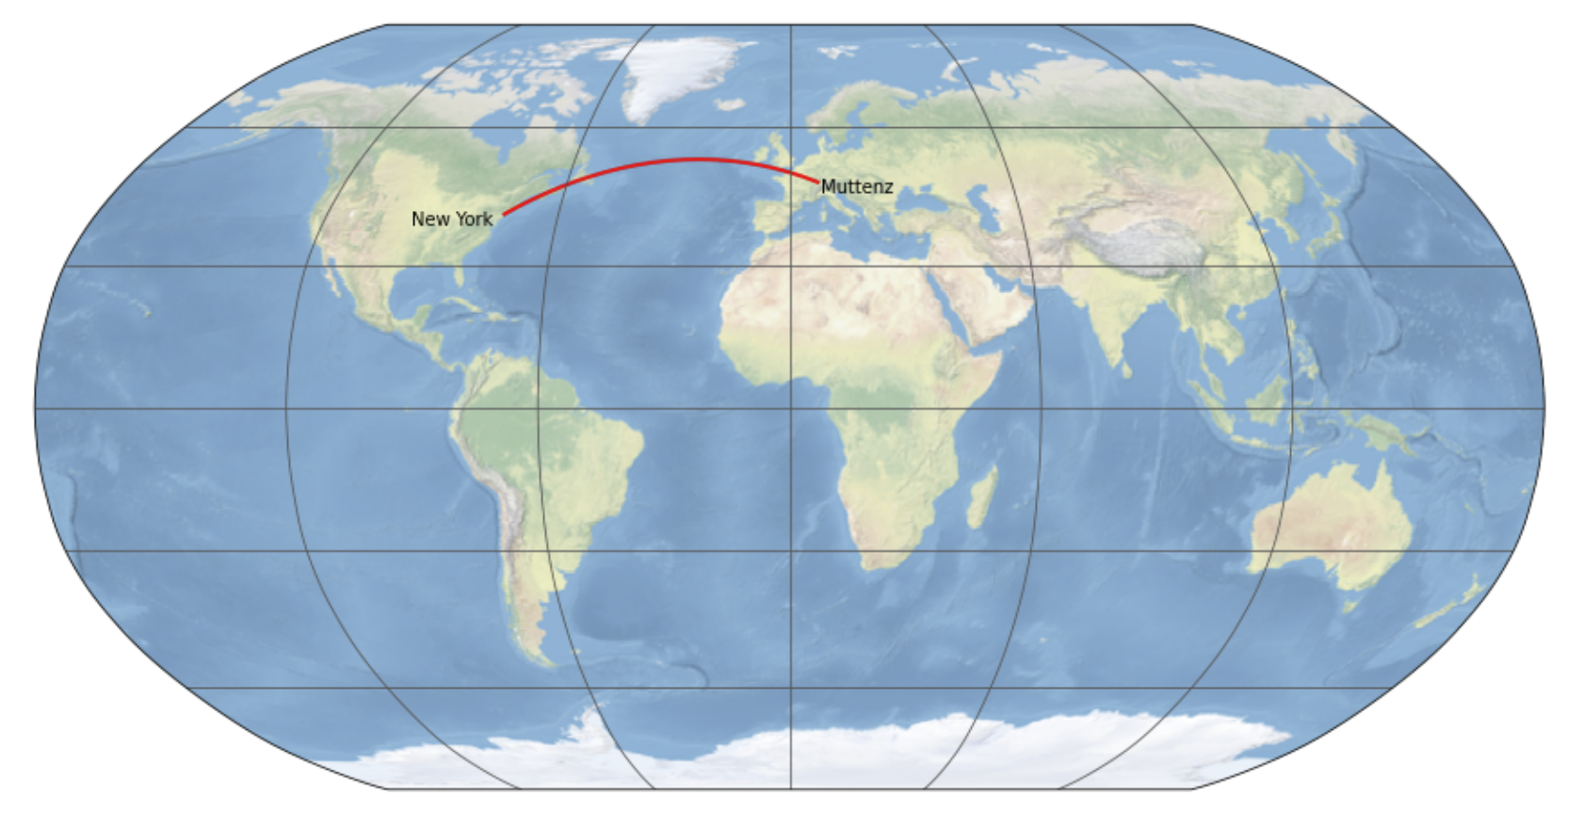

plt.figure(figsize=(15, 9))

ax = plt.axes(projection=ccrs.GOOGLE_MERCATOR)

ax.gridlines(color="#555555")

ax.stock_img()

plt.text(lngNewYork-2, latNewYork-2, 'New York', horizontalalignment='right', transform=ccrs.Geodetic())

plt.text(lngMuttenz+20, latMuttenz-2, 'Muttenz', horizontalalignment='right', transform=ccrs.Geodetic())

plt.plot(lng, lat, 'r-', linewidth=2, transform=ccrs.Geodetic())

plt.show()

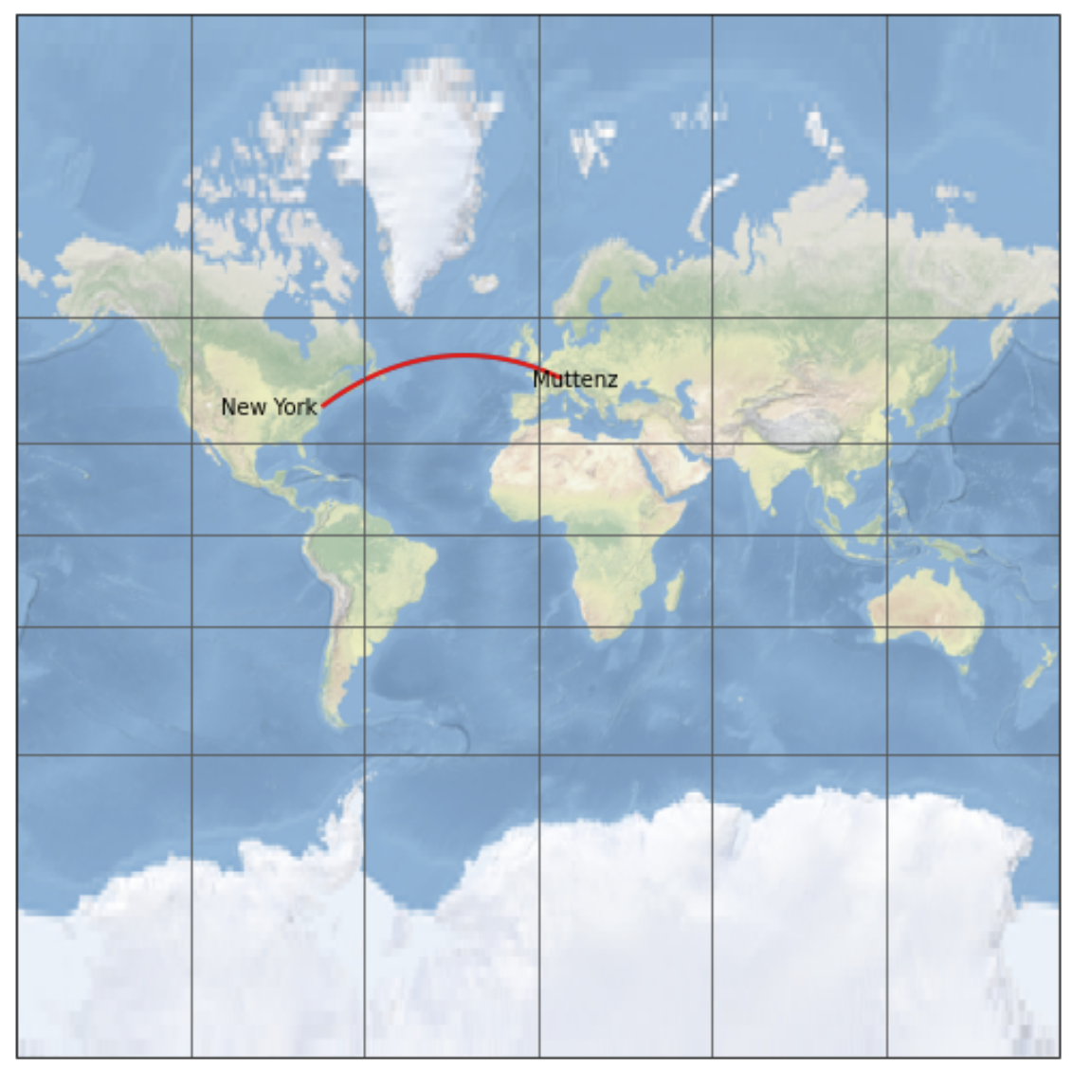

**Ausschnitt (extent)**

import cartopy.crs as ccrs

import matplotlib.pyplot as plt

import cartopy.feature as cf

plt.figure(figsize=(15, 9))

ax = plt.axes(projection=ccrs.PlateCarree())

ax.coastlines()

ax.add_feature(cf.BORDERS)

ax.set_extent([5.96,10.49,45.82,47.81])

latMuttenz, lngMuttenz = 47.534833023418976, 7.6418778566047125

plt.plot(lngMuttenz, latMuttenz, 'ro', transform=ccrs.Geodetic())

plt.text(lngMuttenz+0.02, latMuttenz-0.05, 'Muttenz', transform=ccrs.Geodetic())

plt.show()

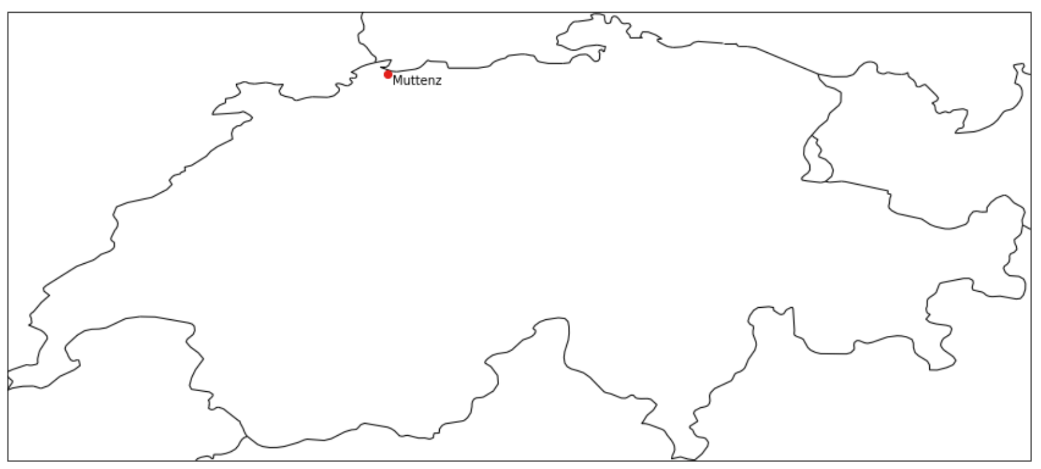

**Mit Web-Merctor (EPSG:3857)**

import cartopy.feature as cf

plt.figure(figsize=(15, 9))

ax = plt.axes(projection=ccrs.GOOGLE_MERCATOR)

ax.coastlines()

ax.add_feature(cf.BORDERS)

ax.set_extent([5.96,10.49,45.82,47.81])

latMuttenz, lngMuttenz = 47.534833023418976, 7.6418778566047125

plt.plot(lngMuttenz, latMuttenz, 'ro', transform=ccrs.Geodetic())

plt.text(lngMuttenz+0.02, latMuttenz-0.05, 'Muttenz', transform=ccrs.Geodetic())

plt.show()

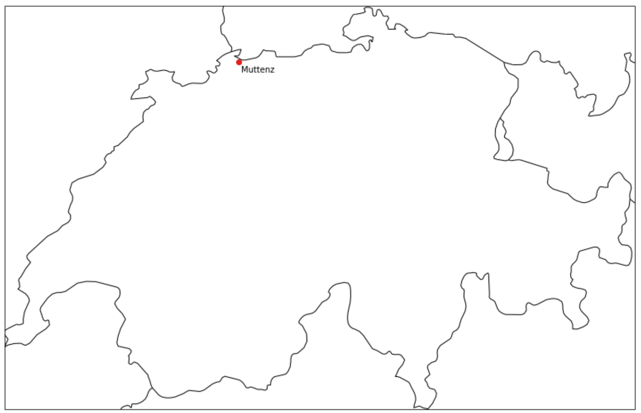

**Kantone mit Cartopy**

import geopandas as gpd

kantone = gpd.read_file("daten/gemeindegrenzen/ggg_2021-LV95/shp/g1k21.shp", encoding="utf-8")

**Nach WGS84 transformieren und als Shapefile speichern:**

kantonewgs84 = kantone.to_crs("EPSG:4326")

kantonewgs84.to_file("daten/kantoneWGS84.shp", driver="Shapefile", encoding="utf-8")

Cartopy Shapereader

import cartopy.io.shapereader as shpreader

reader = shpreader.Reader("daten/kantoneWGS84.shp")

for record in reader.records():

    print(record.attributes["KTNAME"], str(record.geometry)[0:100])

Zürich POLYGON ((8.669605788370836 47.67475467340421, 8.676874952790913 47.6718171838336, 8.677959703624504 Bern / Berne MULTIPOLYGON (((7.09126653424764 46.90346257216019, 7.09741800287087 46.89996396287859, 7.1032224250 Luzern POLYGON ((8.258595258875983 47.28719707625456, 8.261630148036334 47.28254304580119, 8.27065758064512

…

from cartopy.feature import ShapelyFeature

import cartopy.io.shapereader as shpreader

import random

plt.figure(figsize=(15, 9))

ax = plt.axes(projection=ccrs.PlateCarree())

ax.set_extent([5.96,10.49,45.82,47.81])

reader = shpreader.Reader("daten/kantoneWGS84.shp")

for record in reader.records():

    r = random.random()

    g = random.random()

    b = random.random()

    shape_feature = ShapelyFeature([record.geometry], ccrs.PlateCarree(), fc=(r,g,b), ec='black', lw=1)

    ax.add_feature(shape_feature)

plt.show()

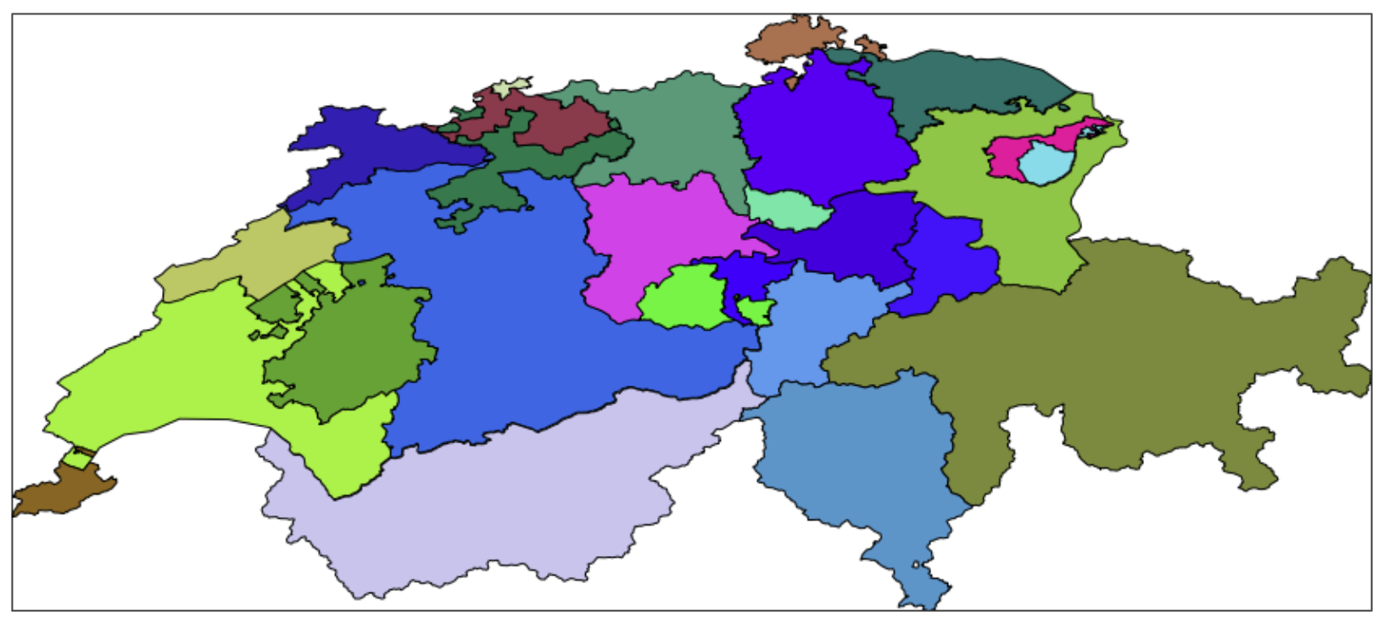

from cartopy.feature import ShapelyFeature

import cartopy.io.shapereader as shpreader

import random

plt.figure(figsize=(15, 9))

ax = plt.axes(projection=ccrs.GOOGLE_MERCATOR)

ax.set_extent([5.96,10.49,45.82,47.81])

reader = shpreader.Reader("daten/kantoneWGS84.shp")

for record in reader.records():

    r = random.random()

    g = random.random()

    b = random.random()

    shape_feature = ShapelyFeature([record.geometry], crs=ccrs.PlateCarree(), fc=(r,g,b), ec='black', lw=1)

    ax.add_feature(shape_feature)

plt.box(False)

plt.show()

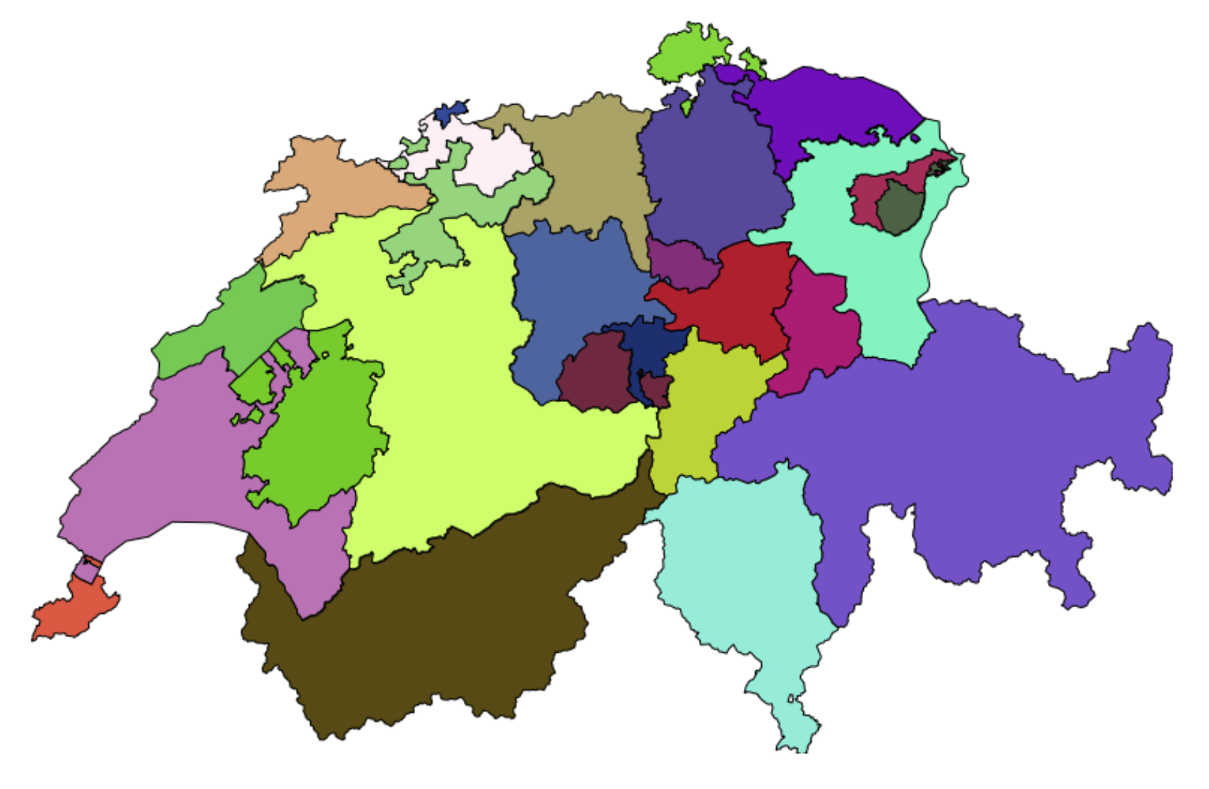

**Alternative: Shapefile mit GeoPandas lesen**

kantone = gpd.read_file("daten/kantoneWGS84.shp", encoding="utf-8")

**Zugriff auf Daten mit iloc**

df.iloc(0)[i]["ATTRIBUT"]

kantone.iloc(0)[0]

KTNR 1  
KTNAME Zürich  
GRNR 4  
AREA_HA 172894  
X_MIN 669245  
X_MAX 716900  
Y_MIN 223896  
Y_MAX 283343  
X_CNTR 691800  
Y_CNTR 252000  
Z_MIN 330  
Z_MAX 1291  
Z_AVG 533  
Z_MED 505  
E_MIN 2669245  
E_MAX 2716900  
N_MIN 1223896  
N_MAX 1283343  
E_CNTR 2691800  
N_CNTR 1252000  
Shape_Leng 284843.337695  
Shape_Area 1729058104.04  
geometry POLYGON ((8.669605788370836 47.67475467340421,...  
Name: 0, dtype: object

kantone.iloc(0)[0]["geometry"]

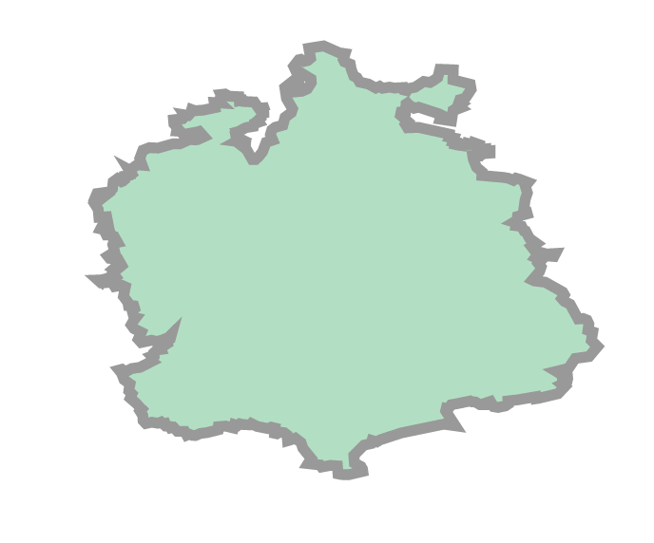

**Schwerpunkt des Polygons**

centroid = kantone.iloc(0)[0]["geometry"].centroid

x = centroid.x

y = centroid.y

print(x,y)

8.655116819326395 47.41298181137762

**Bounding Box des Polygons**

bounds = kantone.iloc(0)[0]["geometry"].bounds

bounds

(8.357826373516879, 47.1594443573009, 8.985038092665208, 47.6945618446393)

from cartopy.feature import ShapelyFeature

import geopandas as gpd

import random

plt.figure(figsize=(15, 9))

ax = plt.axes(projection=ccrs.GOOGLE_MERCATOR)

ax.set_extent([5.96,10.49,45.82,47.81])

kantone = gpd.read_file("daten/kantoneWGS84.shp", encoding="utf-8")

for i in range(0, len(kantone)):

    r = random.random()

    g = random.random()

    b = random.random()

    geometry = kantone.iloc(0)[i]["geometry"]

    name = kantone.iloc(0)[i]["KTNAME"]

    shape_feature = ShapelyFeature([geometry], crs=ccrs.PlateCarree(), fc=(r,g,b), ec='black', lw=1)

    ax.add_feature(shape_feature)

plt.box(False)

plt.show()

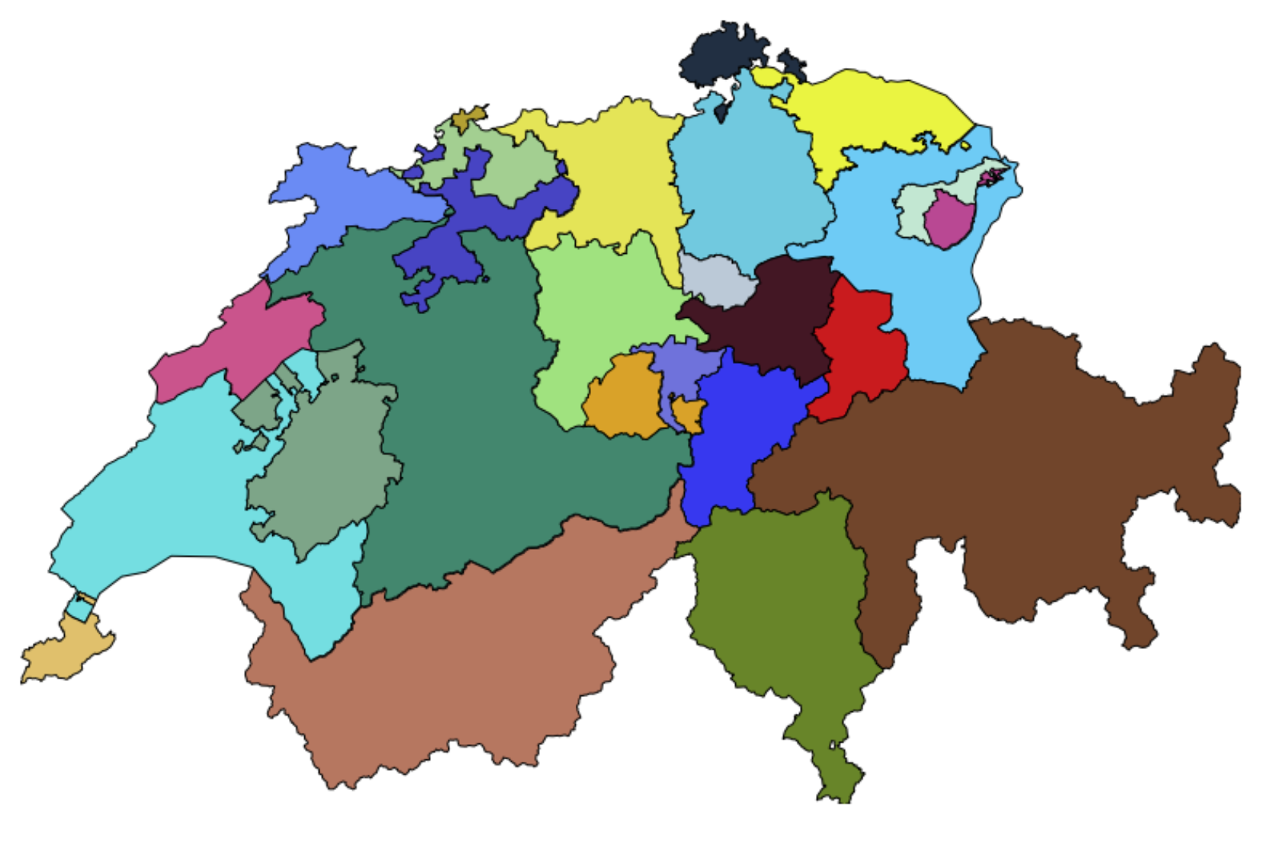

**Einzelnes Polygon plotten**

kantone = gpd.read_file("daten/kantoneWGS84.shp", encoding="utf-8")

bern = kantone.query("KTNR == 2")

bern.iloc(0)[0]["geometry"]

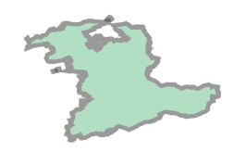

from cartopy.feature import ShapelyFeature

import geopandas as gpd

import random

plt.figure(figsize=(15, 9))

ax = plt.axes(projection=ccrs.GOOGLE_MERCATOR)

kantone = gpd.read_file("daten/kantoneWGS84.shp", encoding="utf-8")

bern = kantone.query("KTNR == 2")

geometry = bern.iloc(0)[0]["geometry"]

bbox = geometry.bounds

ax.set_extent([bbox[0],bbox[2],bbox[1],bbox[3]])

shape_feature = ShapelyFeature([geometry], crs=ccrs.PlateCarree(), fc="green", ec='black', lw=1)

ax.add_feature(shape_feature)

#plt.box(False)

plt.show()

